NUTRITION ASSISTANT APPLICATION

**IBM-Project-7841-1658900588**

**TEAM ID: PNT2022TMID04910**

**Submitted by**

**AMBARISH PRIYAN.P 921319104019**

**ABIMANYU.A 921319104006**

**ALAGAPPAN.K 921319104018**

**AKASH.T 921319104016**

**In partial fulfilment for the award of the degree of**

**BACHELOR OF ENGINEERING**

**in**

**COMPUTER SCIENCE AND ENGINEERING**

**PSNA COLLEGE OF ENGINEERING AND TECHNOLOGY**

**DINDIGUL- 624622**

**INDEX**

# INTRODUCTION

* 1. Project Overview
  2. Purpose

# LITERATURE SURVEY

* 1. Existing solutions
  2. References
  3. Problem Statement Definition

# IDEATION & PROPOSED SOLUTION

* 1. Empathy Map Canvas
  2. Ideation & Brainstorming
  3. Proposed Solution
  4. Problem Solution fit

# REQUIREMENT ANALYSIS

* 1. Functional requirement
  2. Non-Functional requirements

# PROJECT DESIGN

* 1. Data Flow Diagrams
  2. Solution & Technical Architecture
  3. User Stories

# PROJECT PLANNING & SCHEDULING

* 1. Sprint Planning & Estimation
  2. Sprint Delivery Schedule
  3. Reports from JIRA

# CODING & SOLUTIONING (Explain the features added in the project along with code)

* 1. Feature 1
  2. Feature 2
  3. Database Schema

# TESTING

* 1. Test Cases
  2. User Acceptance Testing

# RESULTS

* 1. Performance Metrics

# ADVANTAGES & DISADVANTAGES

1. **CONCLUSION**

# FUTURE SCOPE

1. **APPENDIX**

Source Code

GitHub & Project Demo Link

# NUTRIAUX - NUTRITION ASSISTANT APPLICATION

1. **INTRODUCTION**

# Project Overview

Due to the ignorance of healthy food habits, obesity rates are increasing at an alarming speed, and this is reflective of the risks to people’s health. People need to control their daily calorie intake by eating healthier foods, which is the most basic method to avoid obesity. However, although food packaging comes with nutrition (and calorie) labels, it’s still not very convenient for people to refer to App-based nutrient dashboard systems which can analyze real-time images of a meal and analyze it for nutritional content which can be very handy and improves the dietary habits, and therefore, helps in maintaining a healthy lifestyle.

This project aims at building a web App that automatically estimates food attributes such as ingredients and nutritional value by classifying the input image of food and provide it’s nutritional values. Our method employs “**Clarifai's AI-Driven Food Detection Model**” for accurate food identification and “**Spoonacular Nutrition API**” to give the nutritional value of the identified food. Clarifai AI-Driven Food Detection Model is an API that classifies the ingredients of the meal and provide the name of the meal. That name will be provided as an input to the Spoonacular API which provides the nutritional value of the identified food.

# Purpose

Basically, a diet and nutrition app comes with lots of benefits. It helps users in:

* + - To keep track of daily intake
    - To monitor calories intake
    - To provide facility to upload meal image
    - To get nutritional value of the uploaded image
    - To keep track of BMI

# LITERATURE SURVEY

* 1. **Existing solutions**

# MY FITNESS PAL [1]

Mobile applications that count calories, such as My Fitness Pal, are frequently employed on a daily basis. Recent research has shown that in undergraduates, calorie tracking is associated with eating disorder pathology. In the current study (N = 105 individuals diagnosed with an eating disorder), we assessed usage of My Fitness Pal to track calories. We also assessed perceptions that My Fitness Pal contributed to eating disorder symptoms and if these perceptions were associated with eating disorder symptoms. We found that a substantial percentage (~ 75%) of participants used My Fitness Pal and that 73% of these users perceived the app as contributing to their eating disorder. Furthermore, we found that these perceptions were correlated with eating disorder symptoms.

This research suggests that My Fitness Pal is widely used in an eating disorder population and is perceived as contributing to eating disorder symptoms. Further research is needed to clarify the role calorie tracking applications play within a sample of individuals with eating disorders. It can be tailored to fit the needs of anyone with specific and/or doctor/dietitian-recommended requirements. MyFitnessPal’s community aspect basically consists of a forum, where other fellow users of the app are free to exchange tips and advice, as well as to create relationships through sharing personal experiences or struggles.

MyFitnessPal has more than 350 exercise stored in its database, and it shows how much each person burns during each activity, based on their specific height, weight, and gender. It includes most cardio and strength training workouts, as well as yoga and Pilates. The free application is available for Blackberry, Android, Windows, and the iPhone.

# NUTRI ASSISTANT [2]

NutriAssistant dedicates itself to the development of software in the cloud, with connection to web and mobile applications, for Professionals and any other Users. NutriAssistant is a work tool that is designed to be used by a trained nutrition Professionals. That software, NutriAssistant, enables the simplification of complex tasks, such as management and analysis of nutritional information of the Professions’ clients. We consider 46 macro and micro nutrients as well as allergies and religious preferences. With NutriAssistant the Customer can plan, analyze and create professional grade weekly meal plans. NutriAssistant can generate meal plans and recipes automatically, based on parameters submitted by the User However, NutriAssistant cannot provide medical or health advice, dietary recommendations, or produce diagnosis for any patients. It is the responsibility of the User that the use of NutriAssistant meet the local dietary, health and other regulations. With NutriAssistant the Customer can plan, analyze and create professional grade weekly meal plans. If the User generates any kind of nutrition-related document in NutriAssistant, including meal plans, recipes, reports, and food analysis. NutriAssistant is not liable for any adverse effects, issues, or complications any patient or client may experience after implementing a meal plan or recipe created by using NutriAssistant in their lifestyle. NutriAssistant will endeavor to keep all nutritional facts, including nutrient data, recipe and diet information as accurate and up-to-date as possible. NutriAssistant will not be responsible for generating any meal plans or recipes that contain allergens the User wishes to avoid. Recipes and Menus that are created or amended by the User are owned by the Company.

# PERSONALIZED DIETARY ASSISTANT [3]

As the Internet gains dominance as the primary source of information in the daily life of people, it is naturally among the first places one would start looking for such information, although numerous online sources have been shown to lack accuracy considering dietary guidelines. Nowadays, there are numerous types of diets that aim to improve the quality of life, health and longevity of people. However, these diets typically involve a strictly planned regime, which can be hard to get used to or even to follow

through at all, due to the sudden nature of the change. In this paper, the framework for an Intelligent Space application is proposed that helps its users to achieve a healthier diet in the long term by introducing small, gradual changes into their consumption habits. The application observes the daily nutrition intake of its users, applies data mining in order to learn their personal tastes, and educates them about the effects of their current diet on their health. Then it analyzes the knowledge base to find different food or drink items that align with the perceived preferences, while also add to the balance of the daily nutrition of the users considering their physical properties, activities, and health conditions (e.g. diabetes, celiac disease, food allergies, etc). Finally, the system uses the findings to make suggestions about adding items from the consumption list, or change one item to another.

# POPULAR NUTRITION-RELATED MOBILE APPS A FEATURE ASSESSMENT[4]

A key challenge in human nutrition is the assessment of usual food intake. This is of particular interest given recent proposals of eHealth personalized interventions. The adoption of mobile phones has created an opportunity for assessing and improving nutrient intake as they can be used for digitalizing dietary assessments and providing feedback. This study aims to analyze the main features of the most popular nutrition apps and to compare their strategies and technologies for dietary assessment and user feedback. Apps were selected from the Google Play Store for Android and the iTunes App Store for iOS based on popularity as measured by the number of installs and reviews. Results - A total of 13 apps were classified as popular for inclusion in the analysis. Nine apps offered prospective recording of food intake using a food diary feature. Food selection was available via text search or barcode scanner technologies. Portion size selection was only textual (i.e, without images or icons). All nine of these apps were also capable of collecting physical activity (PA) information using self-report, the global positioning system (GPS), or wearable integrations. Their outputs focused predominantly on energy balance between dietary intake and PA. None of these nine apps offered features directly related to diet plans and motivational coaching. In contrast, the remaining four of the 13 apps focused on these opportunities, but without food diaries.

Conclusions: The high number of installs indicates that there is a clear interest and opportunity for diet monitoring and recommendation using mobile apps. All the apps collecting dietary intake used the same nutrition assessment method (ie, food diary record) and technologies for data input (ie, text search and barcode scanner). Emerging technologies, such as image recognition, natural language processing, and artificial intelligence, were not identified.

# NUTRITRACK: ANDROID-BASED FOOD RECOGNITION APP FOR NUTRITION AWARENESS [5]

The use of smartphone technology has created new opportunities for people to be aware about health and wellness using diet monitoring applications. Proliferation of such applications have been manifested in the society and that using a smartphone and mobile technology nowadays become universal. One of the emergent concerns of human life is about health and wellness. Undeniably, health and nutrition are one of the valuable aspects of life. Thus, technological innovations to help enhance and even promote health awareness is essential. With the advent of mobile computing, it is much easier to be aware of health information because of its mobility and availability. Much mobile application is being developed to serve as a tool for health monitoring and nutritional guide. Mobile applications have the ability to support health needs like detecting heart rate, classifying food, and many more. Taking advantage of technology, utilization of it hereby addresses certain issue and problems of human life, especially in health. In this study, the researcher's attempts to design and develop an Android-based food recognition application that could be used as a health awareness tool for non-health conscious individual. The application lets the user take the photo of the food and show its nutritional contents. Implementing Mifflin-St Jeor method in determining daily calorie consumption, users shall be aware of their required calorie intake. Moreover, the researchers' have studied its effect on people's health awareness on food nutrition by the randomly selected respondents. Finally, this paper presents an analysis of the impact of the food recognition app to change people's concept of food nutrition.

# References

* + 1. <https://www.myfitnesspal.com/>
    2. <https://www.nutriassistant.com/>
    3. B. Tusor, G. Simon-Nagy, J. T. Tóth and A. R. Várkonyi-Kóczy, "Personalized dietary assistant — An intelligent space application," 2017 IEEE 21st International Conference on Intelligent Engineering Systems (INES), 2017, pp. 000027-000032, doi: 10.1109/INES.2017.8118575.
    4. Zenun Franco, Rodrigo & Fallaize, Rosalind & Lovegrove, Julie & Hwang, Faustina. (2016). Popular Nutrition-Related Mobile Apps: A Feature Assessment. JMIR mhealth and uhealth. 4. 10.2196/mhealth.5846

.

* + 1. A. B. Ocay, J. M. Fernandez and T. D. Palaoag, "NutriTrack: Android-based food recognition app for nutrition awareness," 2017 3rd IEEE International Conference on Computer and Communications (ICCC), 2017, pp. 2099-2104, doi: 10.1109/CompComm.2017.8322907.

# Problem Statement Definition

* People need to control their daily calorie intake by eating healthier foods, which is the most basic method to avoid obesity. However, although food packaging comes with nutrition (and calorie) labels, it is still not very convenient for people to refer.
* App-based nutrient dashboard systems which can analyze real time images of meal and analyze it for nutritional content can be very handy and improve the dietary habit.
* To develop a web application that automatically estimates food attributes such as ingredients and nutritional value by classifying the input image of food provided.

# IDEATION & PROPOSED SOLUTION

* 1. **Empathy Map Canvas**

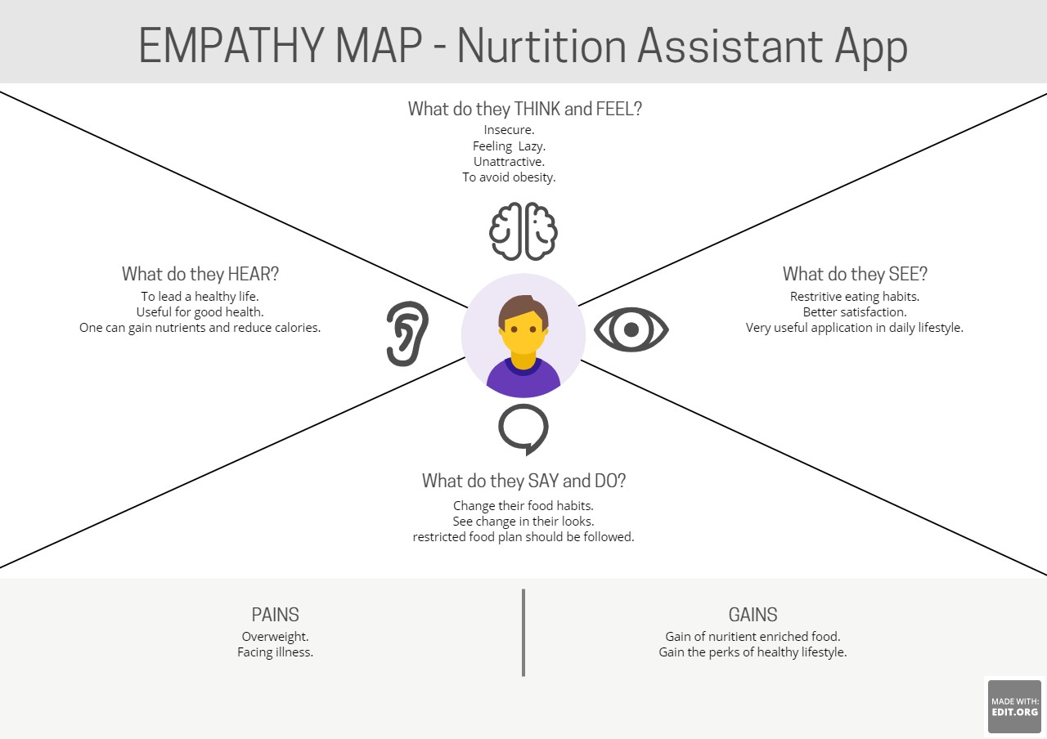

# Ideation & Brainstorming

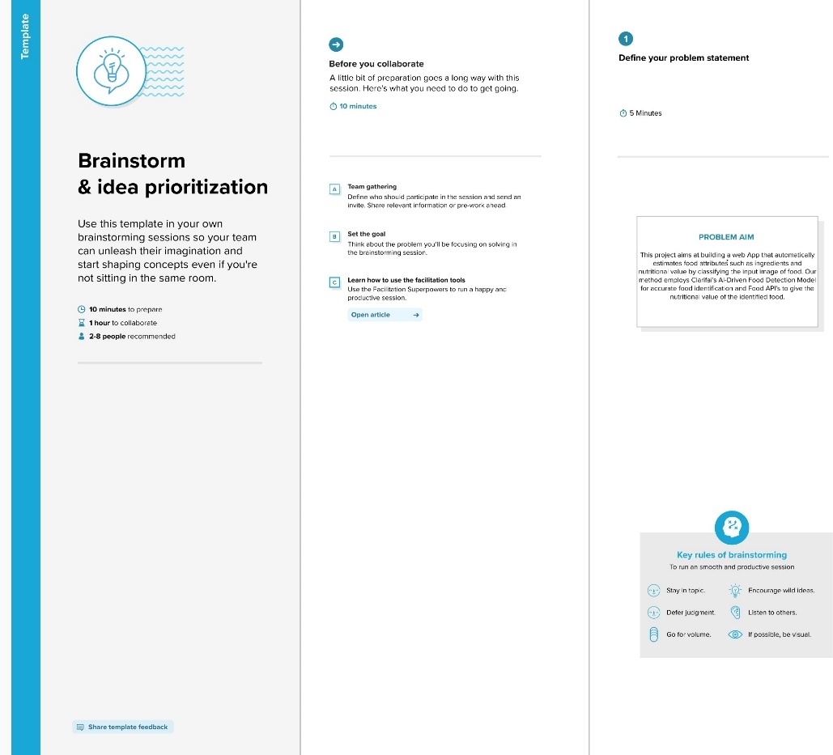

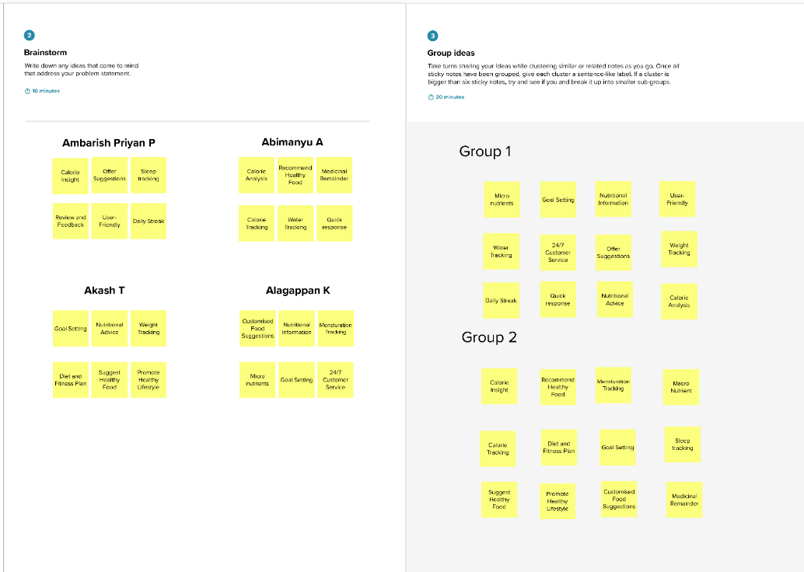

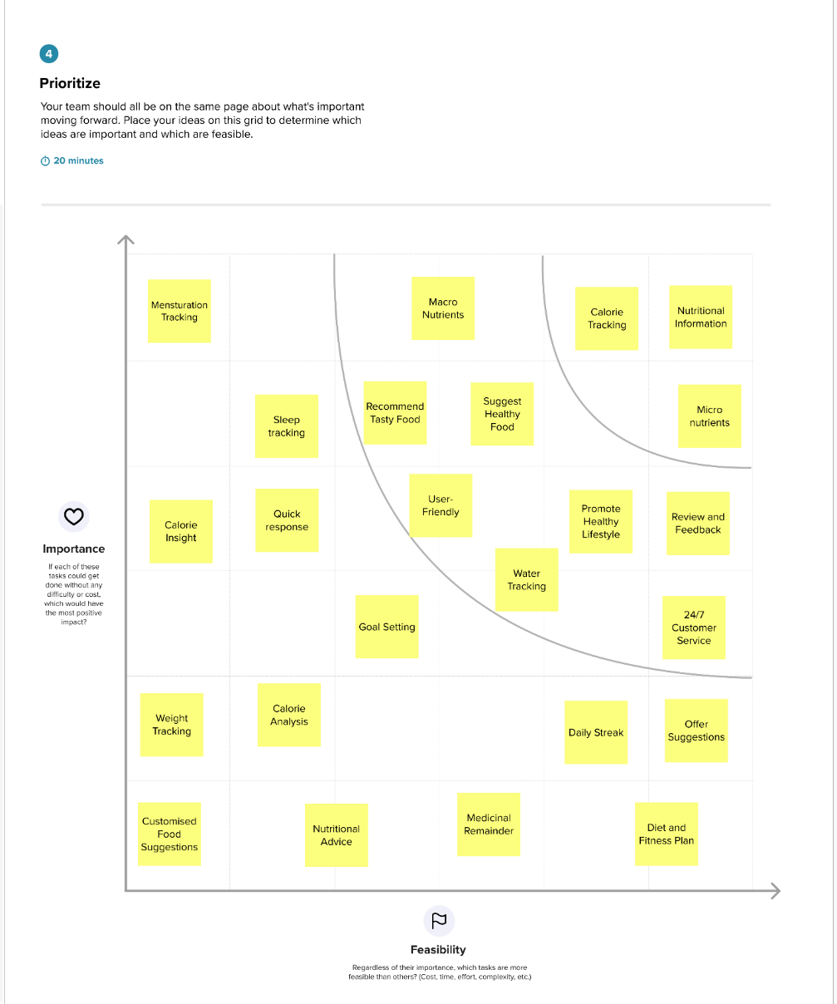

* 1. **Proposed Solution**

|  |  |  |
| --- | --- | --- |
| **S. No.** | **Parameter** | **Description** |
| 1. | Problem Statement (Problem to be solved) | *This project aims at building a web App that automatically estimates food attributes such as ingredients and nutritional value by classifying the input image of food. Our method employs Clarifai's AI-Driven Food Detection Model for accurate food identification and Food APIs to give the nutritional value of the identified food* |
| 2 | Idea / Solution description | *The solution is a responsive web page that can be used on both mobile and computers. Cumulative results of pictures of the food as input and provide nutritional information of food are used to achieve accurate prediction. The website provides a user-friendly interface and accepts multiple samples predicting them simultaneously. A*  *detailed report of the concerned person’s health will be generated.* |
| 3 | Novelty / Uniqueness | * *Patients to More Easily Monitor their caloric intake and dietary Pattern to aid in weight and disease Management.* * *Our method uses Clarifai's AI-driven food recognition model to accurately identify foods.* * *A food API that reports the nutritional value of identified foods.* * *Frequent checking of nutritional value and Customized food suggestions.* * *Water and medicine monitoring* * *Keep a food journal* |
| 4 | Social Impact / Customer Satisfaction | *Calculate the basal metabolic rate, body mass index, ideal weight, and caloric intake. Nutrition-Focused Food Banking.*  *Targeted Food Assistance Programs.* |
| 5 | Business Model (Revenue Model) | *Revenue is generated on a subscription basis, with big data processing and targeted in-depth reporting reviews that paid subscriptions the best.* |
| 6 | Scalability of the Solution | *Furthermore, features can be extended in our application.*  *Additional features such as sleep tracking and menstruation tracking can be done.* |

# Problem Solution fit

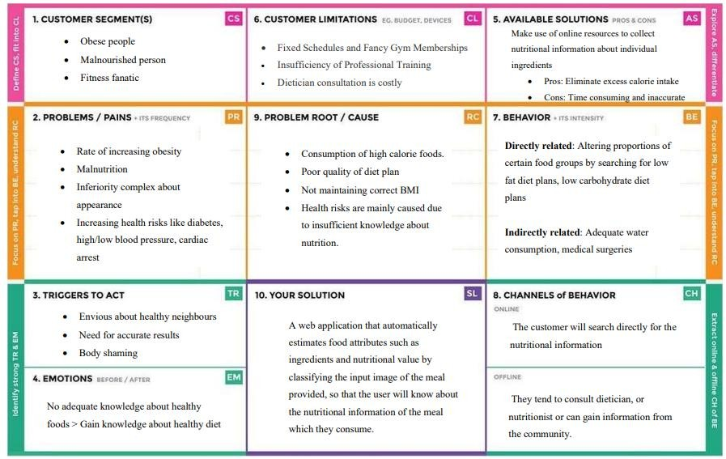

1. **REQUIREMENT ANALYSIS**

# Functional requirement

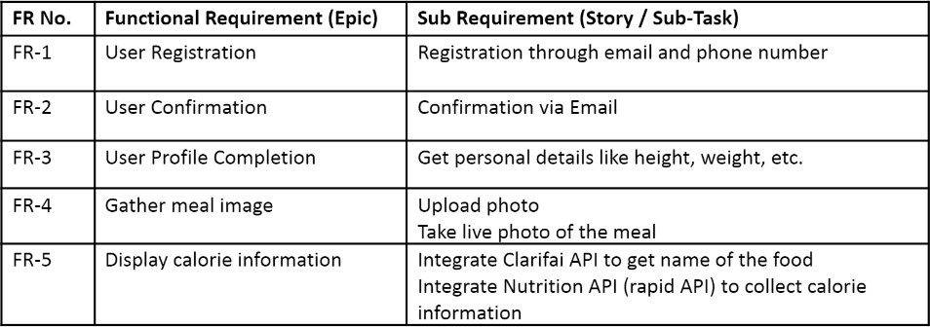

* 1. **Non-Functional requirements**

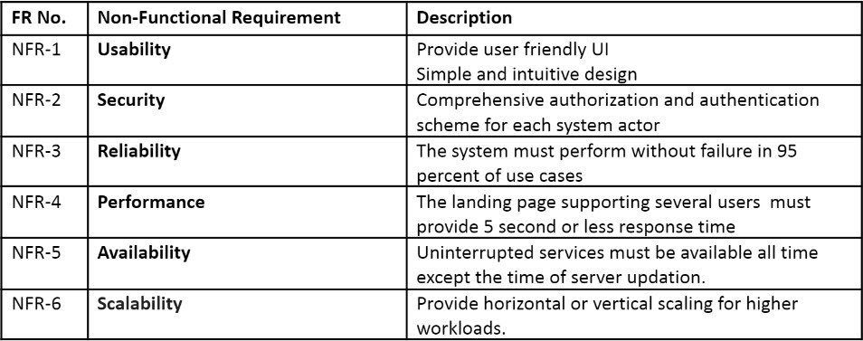

# PROJECT DESIGN

* 1. **Data Flow Diagrams**

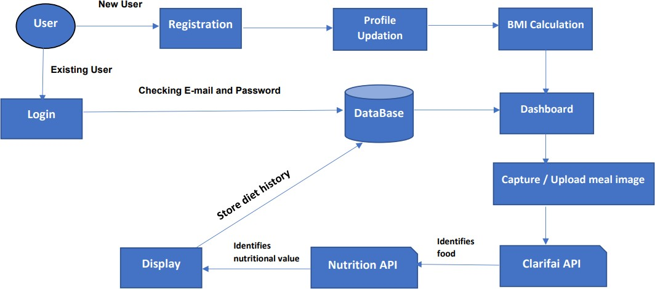

# Solution & Technical Architecture

* + 1. **Solution Architecture**

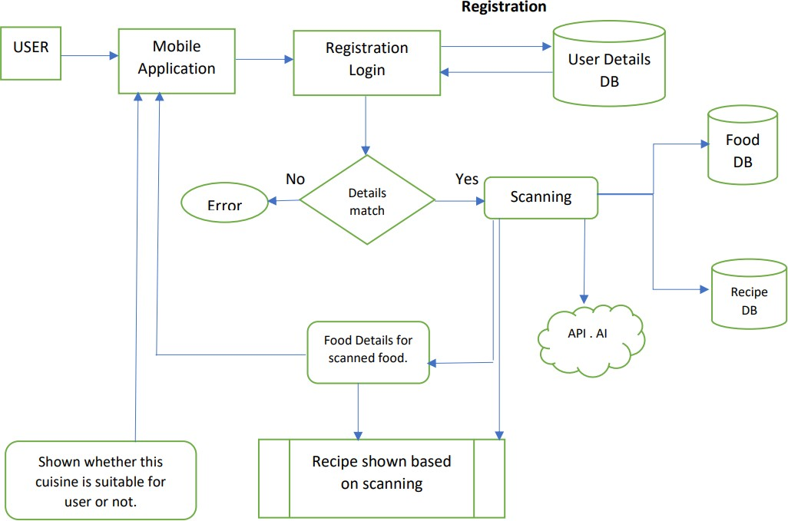

# Technical Architecture

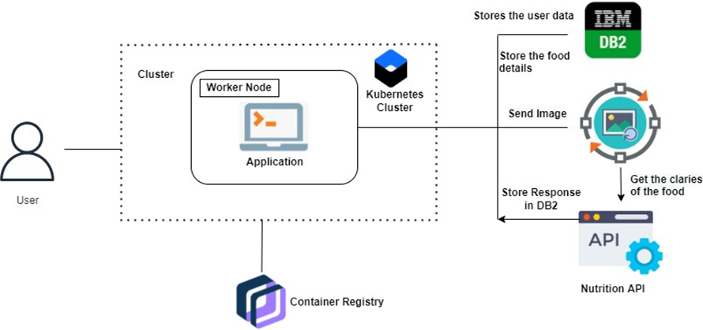

* 1. **User Stories**

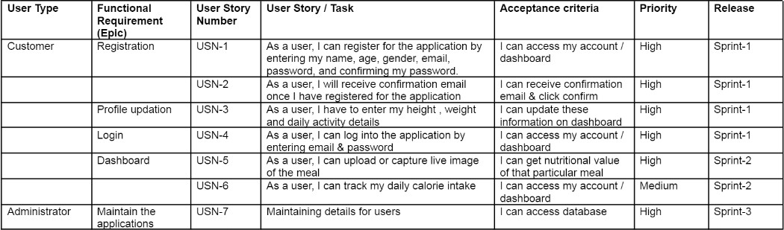

# PROJECT PLANNING & SCHEDULING

* 1. **Sprint Planning & Estimation**





# Sprint Delivery Schedule



* 1. **Reports from JIRA**

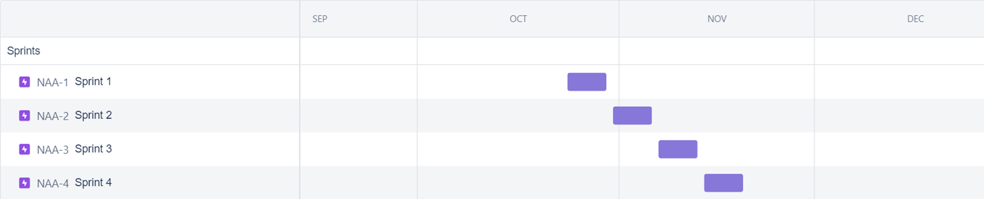

# CODING & SOLUTIONING

* 1. **Feature 1 Home page:**

Nutrition App is a responsive web application which gives the nutritional value of the uploaded meal image. The home page contains information about Nutrition App. It also contains navigation bar with links to Register, Login and Support pages.

# Home.html

<!DOCTYPE html>

<html lang="en">

<head>

<meta charset="UTF-8" />

<meta http-equiv="X-UA-Compatible" content="IE=edge" />

<meta name="viewport" content="width=device-width, initial-scale=1.0" />

<link rel="stylesheet"

href="{{url_for('static',filename='home-style.css')}}"

/>

<title>HOME</title>

<script src="https://kit.fontawesome.com/a076d05399.js"></script>

</head>

<body>

<header>

<img class="logo"

src="{{url_for('static',filename='NutriAux.png')}}" alt="logo"

/>

<nav>

<input type="checkbox" id="check" />

<label for="check" class="checkbtn">

<i class="fas fa-bars"></i>

</label>

<label class="nutri">NutriAux</label>

<ul>

<li><a href="{{url_for('reg')}}">Register</a></li>

<li><a href="{{url_for('login')}}">Login</a></li>

<li><a href="{{url_for('support')}}">Support</a></li>

</ul>

</nav>

</header>

<div class="bg-text">

<p>

<span>NutriAux</span> is a web app that aims at automatically estimating the food attributes such as ingredients and nutritional value by

classifing the input image of the food. The person who wishes to use the app must register before using the app. The user can login to their account to see thier respective dashboard with the details of height, weight, BMI that is automatically generated and the amount of calorie that can be taken according to the BMI of the user. The user can upload the image of the food that he has taken. The app will then display the

nutritional value of the food. The user can take a note of it and can alter his food habits accoring to his BMI and amount of calories that can be intaken. The user can view the history of the food and the calorie intake details in the histroy page. The user can make use of the support in case of any queries.

</p>

</div>

<section></section>

</body>

</html>

# home-style.css

* {

padding: 0;

margin: 0;

text-decoration: none; list-style: none;

font-family: verdana; box-sizing: border-box;

}

body {

background-color: #fdc100;

}

span {

font-size: 30px; text-align: center; font-weight: bold;

}

img.logo { height: 60px; width: 80px; margin: 10px;

}

header { display: flex;

justify-content: space-between; align-items: center;

}

nav {

background-color: #fdc100; height: 80px;

width: 100%;

}

label.nutri { padding: 0 30px; color: black; font-size: 25px;

line-height: 80px; font-weight: bold;

}

nav ul { float: right;

margin-right: 20px;

}

nav ul li {

display: inline-block; line-height: 80px; margin: 0 5px;

}

nav ul li a { color: black; font-size: 17px;

border: 1px solid transparent;

padding: 7px 13px; border-radius: 3px;

}

a.active, a:hover {

background: #80cc66; border: 1px solid white; transition: 0.5s;

}

.checkbtn {

font-size: 30px; color: crimson; float: right;

line-height: 80px; margin-right: 40px; cursor: pointer; display: none;

}

#check { display: none;

}

.bg-text {

background-color: rgb(0, 0, 0); /* Fallback color */

background-color: rgba(0, 0, 0, 0.7); /* Black w/opacity/see-through */ color: white;

border: 3px solid #f1f1f1; position: absolute;

top: 50%;

left: 50%;

transform: translate(-50%, -50%);

z-index: 2;

width: 80%; padding: 10px; text-align: justify; font-size: 22px;

}

@media (max-width: 992px) { label.nutri {

font-size: 30px; padding-left: 50px;

}

nav ul li a {

font-size: 16px;

}

.bg-text {

margin-top: 50px; top: 50%;

left: 50%;

}

}

@media (max-width: 858px) {

.checkbtn { display: block;

}

label.nutri { display: none;

}

.bg-text {

font-size: 15px; top: 50%;

left: 50%;

}

ul {

position: fixed; width: 100%; height: 100vh;

background: #ffee99; z-index: 20;

top: 80px; left: -100%;

text-align: center; transition: all 0.5s;

}

nav ul li { display: block; margin: 50px 0;

line-height: 30px;

}

nav ul li a {

font-size: 20px; color: black;

}

a.active, a:hover {

background: none; border: none; color: #f26d1b;

}

#check:checked ~ ul { left: 0;

}

}

section { width: 100%;

background: url(food2.jpg); background-position: center; background-size: cover; height: calc(100vh - 80px); background-repeat: no-repeat;

}

# Register Page:

The register page asks the user details like First name, Last name, Email, Phone number, Password. After clicking on the register button , we will check whether the user has already registered or not. If they have already registered, they will be directed to login page. If the person does not have an account, then they will receive a confirmation email and will be directed to personal details page.

# Registration.html

<!DOCTYPE html>

<html>

<head>

<meta charset="utf-8" />

<title>Responsive Registration Form</title>

<meta name="viewport"

content="width=device-width, initial-scale=1.0"

/>

<link rel="stylesheet"

href="{{url_for('static',filename='Registration-style.css')}}"

/>

</head>

<body>

<div class="container">

<h1 class="form-title">

<img class="logo"

src="{{url_for('static',filename='NutriAux.png')}}" alt="logo"

/>&emsp;Registration

</h1>

<form action="/register" method="post">

<div class="main-user-info">

<div class="user-input-box">

<label for="firstName">First Name</label>

<input type="text" id="firstName"

name="firstName" placeholder="Enter First Name" required

/>

</div>

<div class="user-input-box">

<label for="lastName">Last Name</label>

<input type="text" id="lastName"

name="lastName" placeholder="Enter Last Name" required

/>

</div>

<div class="user-input-box">

<label for="email">Email</label>

<input type="email" id="email" name="email"

placeholder="Enter Email" required

/>

</div>

<div class="user-input-box">

<label for="phoneNumber">Phone Number</label>

<input type="text"

id="phoneNumber" name="phoneNumber" placeholder="Enter Phone Number" required

/>

</div>

<div class="user-input-box">

<label for="password">Password</label>

<input type="password" id="password" name="password"

placeholder="Enter Password"

pattern="^(?=.*[A-Za-z])(?=.*\d)[A-Za-z\d]{5,}$" required

/>

</div>

<div class="user-input-box">

<label for="confirmPassword">Confirm Password</label>

<input type="password" id="confirmPassword"

name="confirmPassword" placeholder="Confirm Password"

pattern="^(?=.*[A-Za-z])(?=.*\d)[A-Za-z\d]{5,}$" required

/>

</div>

<div>

<span style="color: white; font-size: 13px"

>Password must be minimum Five characters with at least one letter and one number</span

>

</div>

</div>

<div class="form-submit-btn">

<input type="submit" value="Register" />

</div>

<div class="go-back-btn">

<a href="Home.html" class="goback">Go Back</a>

</div>

</form>

</div>

</body>

</html>

# Registration-style.css

@import url(["https://fonts.googleapis.com/](https://fonts.googleapis.com/css2?family=Poppins%3Awght%40200%3B300%3B400%3B500%3B600%3B700&di)c[ss2?family=Poppins:wght@200;300;400;500;600;700&di](https://fonts.googleapis.com/css2?family=Poppins%3Awght%40200%3B300%3B400%3B500%3B600%3B700&di) splay=swap");

* {

padding: 0;

margin: 0;

box-sizing: border-box;

font-family: "Poppins", sans-serif;

}

img.logo { height: 60px; width: 70px; margin: 10px;

}

body { display: flex;

height: 100vh;

justify-content: center; align-items: center;

background-color: #f1f375d7;

background-image: url("calorie_calc_bg.png"); background-blend-mode: color-burn; background-size: 430px 400px;

/*background: linear-gradient(to bottom right, #f9d423 0%, #ff4e50 100%);}*/

}

.container { width: 100%;

max-width: 650px; background: rgba(

0,

0,

0,

0.6

); /*fdc100 - 253,193,0 06837f - 6,131,127 b4ffff - 180,255,255 02cecb - 2,206,203*/

padding: 28px; margin: 0 28px; border-radius: 10px;

box-shadow: inset -2px 2px 2px white;

}

.form-title {

font-size: 26px; font-weight: 600; text-align: center;

padding-bottom: 6px; color: white;

border-bottom: solid 1px white; display: flex;

align-items: center;

}

.main-user-info { display: flex; flex-wrap: wrap;

justify-content: space-between; padding: 15px 0;

}

.user-input-box:nth-child(2n) { justify-content: end;

}

.user-input-box { display: flex; flex-wrap: wrap; width: 50%;

padding-bottom: 12px;

}

.user-input-box label { width: 95%;

color: white; font-size: 20px;

font-weight: 400;

margin: 5px 0;

}

.user-input-box input { height: 30px;

width: 95%; border-radius: 5px; outline: none;

border: 1px solid grey; padding: 0 10px;

}

.gender-title { color: white; font-size: 20px;

font-weight: 400;

}

.gender-category { margin: 20px 0; color: white;

}

.gender-category label { padding: 0 20px 0 2px;

}

.gender-category label,

.gender-category input,

.form-submit-btn input { cursor: pointer;

}

.form-submit-btn { margin-top: 20px;

}

.form-submit-btn input { display: block;

width: 100%; margin-top: 10px; font-size: 20px; padding: 7px; border: none; border-radius: 3px;

color: rgb(255, 255, 255);

background: rgba(253, 193, 0, 0.7);

}

.form-submit-btn input:hover { background: rgba(2, 206, 203, 0.7);

color: rgb(255, 255, 255);

}

.go-back-btn { margin-top: 20px;

}

.go-back-btn a { display: block; width: 100%; margin-top: 10px; font-size: 20px; padding: 7px;

text-decoration: none; border: none;

text-align: center; border-radius: 3px;

color: rgb(255, 255, 255);

background: rgba(253, 193, 0, 0.7);

}

.go-back-btn a:hover {

background: rgba(2, 206, 203, 0.7);

color: rgb(255, 255, 255); cursor: pointer;

}

@media (max-width: 600px) {

.container {

min-width: 280px;

}

.user-input-box { margin-bottom: 12px; width: 100%;

}

.user-input-box:nth-child(2n) { justify-content: space-between;

}

.gender-category { display: flex;

justify-content: space-between; width: 100%;

font-size: 17px;

}

.main-user-info { max-height: 380px; overflow: auto;

}

.main-user-info::-webkit-scrollbar { width: 0;

}

}

# Personal details:

The personal details page asks for age, weight, height, gender, and daily activities of the user. After entering all the details the user has to click the submit button which will direct the user to login page.

# personaldetails.html:

<!DOCTYPE html>

<html lang="en">

<head>

<!-- Required meta tags -->

<meta charset="utf-8" />

<meta name="viewport"

content="width=device-width, initial-scale=1, shrink-to-fit=no"

/>

<!-- Bootstrap CSS -->

<link rel="stylesheet"

href="https://stackpath.bootstrapcdn.com/bootstrap/4.5.2/css/bootstrap.min.css" integrity="sha384-

JcKb8q3iqJ61gNV9KGb8thSsNjpSL0n8PARn9HuZOnIxN0hoP+VmmDGMN5t9UJ0Z" crossorigin="anonymous"

/>

<title>Calorie Calculator</title>

<style> body {

background-color: #f1f375d7;

background-image: url("{{url_for('static',filename='calorie_calc_bg.png')}}"); background-blend-mode: color-burn;

background-size: 430px 400px;

}

.results { display: none;

}

.btn {

background: lighten(#06837f, 3%);

font-weight: 600; letter-spacing: 1px;

}

</style>

</head>

<body>

<div class="container">

<div class="row">

<div class="col-lg-7 mx-auto">

<div class="card card-body text-center mt-5">

<h3 class="heading display-5 pb-3 mb-4"> Enter your personal details

</h3>

<form id="calorie-form" method="post" action="/addpersonaldetails">

<div class="form-group row">

<label for="age" class="col-sm-2 col-form-label">Age</label>

<div class="col-sm-10">

<input type="text"

class="form-control" id="age" name="age"

placeholder="Age > 17"

pattern="(?:1[01][0-9]|120|1[7-9]|[2-9][0-9])$"

required

/>

</div>

</div>

<fieldset class="form-group">

<div class="row">

<legend class="col-form-label col-sm-2 pt-0">Gender</legend>

<div class="col-sm-10" id="form-radio">

<div

class="custom-control custom-radio custom-control-inline"

>

<input type="radio" id="male" name="Gender" value="male"

class="custom-control-input" checked="checked"

/>

<label class="custom-control-label" for="male"

>Male</label

>

</div>

<div

class="custom-control custom-radio custom-control-inline"

>

<input type="radio" id="female" name="Gender" value="female"

class="custom-control-input"

/>

<label class="custom-control-label" for="female"

>Female</label

>

</div>

</div>

</div>

</fieldset>

<div class="form-group row">

<label for="weight" class="col-sm-2 col-form-label"

>Weight</label

>

<div class="col-sm-10">

<input type="number" class="form-control" id="weight" name="weight"

placeholder="In kilograms" required

/>

</div>

</div>

<div class="form-group row">

<label for="height" class="col-sm-2 col-form-label"

>Height</label

>

<div class="col-sm-10">

<input type="number" class="form-control" id="height" name="height"

placeholder="In centimeters" required

/>

</div>

</div>

<div class="form-group row">

<legend class="col-form-label col-sm-2 pt-0">Activity</legend>

<select

class="custom-select col-sm-10 col-lg-9 ml-3" id="list"

name="activity"

>

<option selected value="1"> Sedentary (little or no exercise)

</option>

<option value="2">

Lightly active (light exercise/sports 1-3 days/week)

</option>

<option value="3">

Moderately active (moderate exercise/sports 3-5 days/week)

</option>

<option value="4">

Very active (hard exercise/sports 6-7 days a week)

</option>

<option value="5">

Extra active (very hard exercise/sports & physical job or 2x training)

</option>

</select>

</div>

<div class="form-group" style="margin-top: 70px">

<input type="submit"

value="Proceed to dashboard" class="btn btn-block"

style="background-color: #06837f; color: white"

/>

<input type="button"

onclick="window.history.back()" value="Go Back"

class="btn btn-block"

style="background-color: #06837f; color: white"

/>

</div>

</form>

</div>

</div>

</div>

</div>

<script

src="https://code.jquery.com/jquery-3.5.1.slim.min.js" integrity="sha384-

DfXdz2htPH0lsSSs5nCTpuj/zy4C+OGpamoFVy38MVBnE+IbbVYUew+OrCXaRkfj"

crossorigin="anonymous"

></script>

<script src=["https://](https://cdn.jsdelivr.net/npm/popper.js%401.16.1/dist/umd/popper.min.js)c[dn.jsdelivr.net/npm/popper.js@1.16.1/dist/umd/popper.min.js"](https://cdn.jsdelivr.net/npm/popper.js%401.16.1/dist/umd/popper.min.js) integrity="sha384-

9/reFTGAW83EW2RDu2S0VKaIzap3H66lZH81PoYlFhbGU+6BZp6G7niu735Sk7lN"

crossorigin="anonymous"

></script>

<script src="https://stackpath.bootstrapcdn.com/bootstrap/4.5.2/js/bootstrap.min.js" integrity="sha384-

B4gt1jrGC7Jh4AgTPSdUtOBvfO8shuf57BaghqFfPlYxofvL8/KUEfYiJOMMV+rV" crossorigin="anonymous"

></script>

</body>

</html>

# Login Page:

The user will be asked to enter their registered email and password. After entering correct email and password the user have to click the login button. After that the user will be directed to their respective dashboard.

# Login.html

<! DOCTYPE html>

<html lang="en">

<head>

<meta charset="UTF-8" />

<title>Login Form</title>

<link rel="stylesheet"

href="https://stackpath.bootstrapcdn.com/bootstrap/4.1.3/css/bootstrap.min.css"

/>

</head>

<style> body {

padding-top: 50px; background-color: #f1f375d7;

background-image: url("{{url_for('static',filename='calorie_calc_bg.png')}}"); background-blend-mode: color-burn;

background-size: 430px 400px;

}

.login-form { background: #dcf1f1; margin-top: 40px; margin-bottom: 100px; padding: 50px;

border-radius: 50px;

box-shadow: 10px 10px 5px 0px rgba(0, 0, 0, 0.75);

}

.btn-primary { width: 100%;

}

</style>

<body>

<div class="container">

<div class="row">

<div class="col-md-8 offset-md-2">

<div class="login-form">

<h1 class="text-center" style="padding-bottom: 30px">Login Form</h1>

<form action="/verify" method="post">

<div class="form-group">

<label for="exampleInputEmail1">Enter Email address </label>

<input type="email" name="email"

class="form-control" id="exampleInputEmail1" aria-describedby="emailHelp" placeholder="Enter email" required

/>

<small id="emailHelp" class="form-text text-muted"> We'll never share your email with anyone else.

</small>

</div>

<div class="form-group">

<label for="exampleInputPassword1"> Enter Password </label>

<input type="password" class="form-control" id="password" name="password"

placeholder="Password"

pattern="^(?=.*[A-Za-z])(?=.*\d)[A-Za-z\d]{5,}$" required

/>

</div>

<div class="form-group form-check">

<input type="checkbox"

class="form-check-input"

onclick="showpass()"

/>

<label class="form-check-label" for="exampleCheck1"> Show Password

</label>

</div>

<span style="color: red">{{message}}</span>

<button type="submit"

class="btn btn-primary" style="margin-top: 10px"

>

Submit

</button>

</form>

</div>

</div>

</div>

</div>

<script>

function showpass() {

var x = document.getElementById("password"); if (x.type === "password") {

x.type = "text";

} else {

x.type = "password";

}

}

</script>

<script

src="https://code.jquery.com/jquery-3.3.1.slim.min.js"

integrity="sha384- q8i/X+965DzO0rT7abK41JStQIAqVgRVzpbzo5smXKp4YfRvH+8abtTE1Pi6jizo"

crossorigin="anonymous"

></script>

<script src="https://cdnjs.cloudflare.com/ajax/libs/popper.js/1.14.7/umd/popper.min.js" integrity="sha384-

UO2eT0CpHqdSJQ6hJty5KVphtPhzWj9WO1clHTMGa3JDZwrnQq4sF86dIHNDz0W1" crossorigin="anonymous"

></script>

<script src="https://stackpath.bootstrapcdn.com/bootstrap/4.3.1/js/bootstrap.min.js" integrity="sha384-

JjSmVgyd0p3pXB1rRibZUAYoIIy6OrQ6VrjIEaFf/nJGzIxFDsf4x0xIM+B07jRM" crossorigin="anonymous"

></script>

<script></script>

</body>

</html>

# Feature 2 Dashboard page:

The user’s personal details such as height, weight, BMI and daily calorie intake will be displayed in their respective dashboard. The user can select either upload image option or track history option. This page will contain a navbar with link to support page and a log out option which will redirect the user to Home page.

# dashboard.html

<!DOCTYPE html>

<html>

<head>

<title>

Dashboard

</title>

<meta name="viewport" content="width=device-width , initial-scale=1.0">

<link rel="stylesheet"

href=["https://](https://cdn.jsdelivr.net/npm/bootstrap%404.6.1/dist/css/bootstrap.min.css)c[dn.jsdelivr.net/npm/bootstrap@4.6.1/dist/css/bootstrap.min.css"](https://cdn.jsdelivr.net/npm/bootstrap%404.6.1/dist/css/bootstrap.min.css)>

<script src=["https://](https://cdn.jsdelivr.net/npm/jquery%403.6.0/dist/jquery.slim.min.js)c[dn.jsdelivr.net/npm/jquery@3.6.0/dist/jquery.slim.min.js](https://cdn.jsdelivr.net/npm/jquery%403.6.0/dist/jquery.slim.min.js)"></script>

<script src=["https://](https://cdn.jsdelivr.net/npm/popper.js%401.16.1/dist/umd/popper.min.js)c[dn.jsdelivr.net/npm/popper.js@1.16.1/dist/umd/popper.min.js](https://cdn.jsdelivr.net/npm/popper.js%401.16.1/dist/umd/popper.min.js)"></script>

<link href=["https://cdn.jsdelivr.net/npm/](https://cdn.jsdelivr.net/npm/bootstrap%405.0.2/dist/css/bootstrap.min.css)b[ootstrap@5.0.2/dist/css/bootstrap.min.css"](https://cdn.jsdelivr.net/npm/bootstrap%405.0.2/dist/css/bootstrap.min.css) rel="stylesheet" integrity="sha384-

EVSTQN3/azprG1Anm3QDgpJLIm9Nao0Yz1ztcQTwFspd3yD65VohhpuuCOmLASjC" crossorigin="anonymous">

<script src=["https://](https://cdn.jsdelivr.net/npm/bootstrap%405.2.2/dist/js/bootstrap.bundle.min.js)c[dn.jsdelivr.net/npm/bootstrap@5.2.2/dist/js/bootstrap.bundle.min.js"](https://cdn.jsdelivr.net/npm/bootstrap%405.2.2/dist/js/bootstrap.bundle.min.js) integrity="sha384- OERcA2EqjJCMA+/3y+gxIOqMEjwtxJY7qPCqsdltbNJuaOe923+mo//f6V8Qbsw3" crossorigin="anonymous"></script>

<link rel="stylesheet" href="https://cdnjs.cloudflare.com/ajax/libs/font- awesome/4.7.0/css/font-awesome.min.css">

<link rel="stylesheet" href="{{url_for('static',filename='dashboard.css')}}">

</head>

<body>

<nav class="navbar navbar-expand-lg ">

<div class="container-fluid">

<img class="navbar-brand" src="{{url_for('static',filename='NutriAux.png')}}" alt="NutriAux" height="60px" width="60px" ><h3 style="color: white; margin-left: 30px;margin-top: 15px;">Dashboard</h3>

<button class="navbar-toggler" type="button" data-bs-toggle="collapse" data-bs- target="#navbarNav" aria-controls="navbarNav" aria-expanded="false" aria-label="Toggle navigation">

<i class="fa fa-bars" style="font-size:36px"></i>

</button>

<div class="collapse navbar-collapse" id="navbarNav">

<ul class="navbar-nav ml-auto text-right">

<li class="nav-item">

<a class="nav-link" href="{{url_for('support')}}">Support</a>

</li>

<li class="nav-item ">

<a class="nav-link" href="{{url_for('home')}}">Logout</a>

</li>

</ul>

</div>

</div>

</div>

</nav>

<div class="container">

<div class="row ">

<div class="column border box">

<img src="{{url_for('static',filename='height.jpg')}}" class="rounded-circle" alt="height" id="pic" >

<h4>Height: {{height}} </h4>

</div>

<div class="column border box">

<img src="{{url_for('static',filename='weight.png')}}" class="rounded-circle" alt="weight" id="pic" >

<h4>Weight: {{weight}} </h4>

</div>

</div>

<div class="row my-0 ">

<div class="column border box">

<img src="{{url_for('static',filename='bmi.jpg')}}"class="rounded-circle" alt="bmi" id="pic" >

<h4>BMI: {{BMI}} </h4>

</div>

<div class="column border box">

<img src="{{url_for('static',filename='caloriesintake.png')}}" class="rounded- circle" alt="Calorie" id="pic" >

<h4>Calorie Intake: {{daily_calorie_intake}} </h4>

</div>

</div>

<div class="row">

<div class="column">

<a href="{{url_for('upload')}}" id="bu1" class="btn btn-info btn-lg">Upload Image</a>

</div>

<div class="column ">

<a href="{{url_for('history')}}" id="bu1" class="btn btn-info btn-lg">Track History</a>

</div>

</div>

</div>

</div>

</div>

</div>

</body>

</html>

# dashboard.css

body{

background-color:#D4F1F4;

}

.nav-item{

text-align: end;

}

.navbar-toggler{

outline: none !important; padding: 0 !important;

}

.navbar-toggler i{ width: 40px;

}

#bu1{

text-decoration: none;

}

.navbar{

background-color:#05445E; top: 0;

width: 100%; overflow: hidden; height: 65px;

}

.nav-link{ color: white;

font-weight: 900; margin-left: 50px; letter-spacing: 2px;

}

.nav-item a:hover{

color: #FDC100;

}

* {

box-sizing: border-box;

}

.row { display: flex;

margin-top: 30px; margin-bottom: 15px;

}

.box{

background-color: #a0dfdf;

}

.container{

margin: 50px auto; width:40%;

text-align: center;

}

.container h3{ color: #272643;

}

.container img{ object-fit:contain;

}

.column { flex: 33.33%; padding: 5px;

margin-right:15px;

}

#pic{

height: 100px; width: 130px;

}

#img{

background-color: #24a0ed; color: black;

padding: 14px 25px; text-align: center; text-decoration: none; display: inline-block;

}

#bu1{

background-color:#05445E ; color: white;

font-weight: 800; font-size: medium; border-style: none; text-align:center;

}

# Upload Image Page:

In this page the user can either choose the meal image from the file or drap and drop the meal image. After uploading the image the user should click the submit button. After clicking the submit button the nutritional value of the meal will be displayed.

# upload.html:

<!DOCTYPE html>

<html>

<head>

<title>Upload image</title>

<link href=["https://cdn.jsdelivr.net/npm/](https://cdn.jsdelivr.net/npm/bootstrap%405.0.2/dist/css/bootstrap.min.css)b[ootstrap@5.0.2/dist/css/bootstrap.min.css"](https://cdn.jsdelivr.net/npm/bootstrap%405.0.2/dist/css/bootstrap.min.css) rel="stylesheet" integrity="sha384-

EVSTQN3/azprG1Anm3QDgpJLIm9Nao0Yz1ztcQTwFspd3yD65VohhpuuCOmLASjC" crossorigin="anonymous">

<link rel="stylesheet" href="https://cdnjs.cloudflare.com/ajax/libs/font- awesome/4.7.0/css/font-awesome.min.css">

<link rel="stylesheet" href="{{url_for('static',filename='upload.css')}}">

</head>

<body>

<script src=["https://](https://cdn.jsdelivr.net/npm/bootstrap%405.2.2/dist/js/bootstrap.bundle.min.js)c[dn.jsdelivr.net/npm/bootstrap@5.2.2/dist/js/bootstrap.bundle.min.js"](https://cdn.jsdelivr.net/npm/bootstrap%405.2.2/dist/js/bootstrap.bundle.min.js) integrity="sha384- OERcA2EqjJCMA+/3y+gxIOqMEjwtxJY7qPCqsdltbNJuaOe923+mo//f6V8Qbsw3" crossorigin="anonymous"></script>

<form action="/getnutri" method="post" enctype="multipart/form-data">

<div class="container uploadOuter ">

<table class="uploadimage">

<tr>

<th><label for="uploadFile" id="file" ><h2>Choose your image to upload</h2><i class="fa fa-file-photo-o" style="font-size:48px;color:red"></i></i>

</label></th>

<th> </th>

<th><h3>OR</h3></th>

<th><span class="dragBox" >

<h2>Drag and Drop image here</h2><i class="fa fa-file-photo-o" style="font- size:48px;color:red"></i>

<input name="file" type="file" onChange="dragNdrop(event)" ondragover="drag()" ondrop="drop()" id="uploadFile" required/>

</span></th>

</tr>

</table>

<button class="btn btn-primary btn-lg" id="b1" onclick="window.history.back()">Go Back </button>

<button class="btn btn-primary btn-lg" id="b1" type="submit" >Submit </button>

</div>

</form>

</div>

</div>

<div>

<table class="table table-bordered"><br/><br/>

<tr>

<th scope="col" style="background-color:#050a30;color:white;">Calories</th>

<td style="background-color:white;">{{calories}}</td>

</tr>

<tr>

<th scope="col" style="background-color:#050a30;color:white;">Protein</th>

<td style="background-color:white;">{{protein}}</td>

</tr>

<tr>

<th scope="col" style="background-color:#050a30;color:white;">Fat</th>

<td style="background-color:white;">{{fat}}</td>

</tr>

<tr>

<th scope="col" style="background-color:#050a30;color:white;">Carbs</th>

<td style="background-color:white;">{{carbs}}</td>

</tr>

</table>

</div>

<div id="preview" style="height:105px"> </div>

</div>

</div>

<script> "use strict";

function dragNdrop(event) {

var fileName = URL.createObjectURL(event.target.files[0]); var preview = document.getElementById("preview");

var previewImg = document.createElement("img"); previewImg.setAttribute("src", fileName); previewImg.setAttribute("width", "100px"); previewImg.setAttribute("height", "100px"); preview.innerHTML = ""; preview.appendChild(previewImg);

}

function drag() {

document.getElementById('uploadFile').parentNode.className = 'draging dragBox';

}

function drop() { document.getElementById('uploadFile').parentNode.className = 'dragBox';

}

</script>

</body>

</html> **upload.css:** body {

background-image: url("calorie_calc_bg.png"); background-color: #f1f375d7;

background-blend-mode: color-burn; background-size: 430px 400px;

}

.uploadOuter { text-align: center; padding: 30px;

}

h2,

h3 {

color: #000c66;

}

table { display: flex;

flex-direction: row; justify-content: center; margin: 10px;

margin-bottom: auto; padding: 20px;

}

#file {

padding: 15px; width: 300px; height: 180px; text-align: center;

border: 2px dotted #050a30; border-radius: 7px;

cursor: pointer; position: relative; color: #000c66;

}

.dragBox { padding: 15px; width: 300px; height: 180px;

border-radius: 7px; margin: 0 auto; position: relative; text-align: center; font-weight: bold; line-height: 95px;

border: 2px dotted #050a30; display: inline-block; transition: transform 0.3s;

}

input[type="file"] { position: absolute; height: 100%;

width: 100%;

opacity: 0;

top: 0;

left: 0;

}

.draging {

transform: scale(1.1);

}

#preview {

text-align: center;

}

img {

max-width: 100%;

}

#b1 {

background-color: #000c66; color: white;

border: none;

}

# Track History Page:

The user will be asked to enter food name and calorie value of the food. After entering, the user must click the add button. After clicking the add button , the user meal history will be added to the table below.

# History.html:

<!DOCTYPE html>

<html lang="en">

<head>

<meta charset="UTF-8" />

<meta name="viewport" content="width=device-width, initial-scale=1.0" />

<meta http-equiv="X-UA-Compatible" content="ie=edge" />

<title>Track history</title>

<link href=["https://cdn.jsdelivr.net/npm/](https://cdn.jsdelivr.net/npm/bootstrap%405.2.2/dist/css/bootstrap.min.css)b[ootstrap@5.2.2/dist/css/bootstrap.min.css"](https://cdn.jsdelivr.net/npm/bootstrap%405.2.2/dist/css/bootstrap.min.css) rel="stylesheet" integrity="sha384-

Zenh87qX5JnK2Jl0vWa8Ck2rdkQ2Bzep5IDxbcnCeuOxjzrPF/et3URy9Bv1WTRi" crossorigin="anonymous"/>

<!--Navbar fonts-->

<link rel="stylesheet" href=["https://](https://cdn.jsdelivr.net/npm/%40fortawesome/fontawesome-)c[dn.jsdelivr.net/npm/@fortawesome/fontawesome-](https://cdn.jsdelivr.net/npm/%40fortawesome/fontawesome-) free@6.2.0/css/fontawesome.min.css" integrity="sha384- z4tVnCr80ZcL0iufVdGQSUzNvJsKjEtqYZjiQrrYKlpGow+btDHDfQWkFjoaz/Zr" crossorigin="anonymous">

<!--Adding icons-->

<!--Date icon and bootstrap alignment-->

<link rel="stylesheet"

href="https://maxcdn.bootstrapcdn.com/bootstrap/3.4.0/css/bootstrap.min.css"/>

<!--Burger icon-->

<script src='https://kit.fontawesome.com/a076d05399.js' crossorigin='anonymous'></script>

<!--Bolt icon-->

<link rel="stylesheet" href="https://cdnjs.cloudflare.com/ajax/libs/font- awesome/4.7.0/css/font-awesome.min.css">

<!--Nav Icon-->

<script src="https://kit.fontawesome.com/a076d05399.js" crossorigin="anonymous"></script>

<!--Link to trackhistorystyle.css file-->

<link rel="stylesheet" href="{{url_for('static',filename='trackhistorystyle.css')}}"/>

</head>

<body>

<!--Navbar-->

<div class="bg">

<nav>

<img src="{{url_for('static',filename='NutriAux.png')}}" style="width:60px; height:55px;margin-right:15px;margin-bottom: 17px;margin-left:15px;"/>

<input type="checkbox" id="check">

<label for="check" class="checkbtn">

<i class="fas fa-bars"></i>

</label>

<label class="logo"><span style="margin-top:5px;">Track History</span></label>

<ul>

<li>

<button class="navbutton" onclick="window.history.back()" ><a >Go Back</a></button>

</li>

<li>

<a href="#">Upload Image</a>

</li>

<li class="nav-item">

<a href="{{url_for('support')}}">Support</a>

</li>

<li class="nav-item">

<a href="{{url_for('home')}}">Log out</a>

</li>

</ul>

</nav>

<div class="container" style="margin-top: 50px;">

<form action='/addhistory' method="POST">

<div class="row">

<div class="col-md-3 mt-3">

<!--component-->

<span style="font-size:17px;">Date:</span>

<div class="input-group date" id="datePicker" >

<span class="input-group-addon">

<i class="glyphicon glyphicon-calendar" style="color:#0b3c49"></i>

</span>

<input type="text"

class="form-control" name="date" id="date"

readonly

style="background-color:white"

/>

</div>

</div>

<div class="col-md-3 mt-3">

<span style="font-size:17px;">Enter the food name:</span>

<div class="input-group date" id="datePicker" >

<span class="input-group-addon" >

<i class='fas fa-hamburger ' style="color:#0b3c49"></i>

</span>

<input type="text"

class="form-control" name="meal_name" id="meal_name"

/>

</div>

</div>

<div class="col-md-3 mt-3">

<span style="font-size:17px;">Enter Calories:</span>

<div class="input-group date" id="datePicker" >

<span class="input-group-addon">

<i class="fa fa-bolt" style=" color:#0b3c49"></i>

</span>

<input type="text"

class="form-control" name="calories" id="calories"

/>

</div></div>

<div class="col-md-3 mt-3" style="margin-left:auto">

<button type="submit" class="btn btn-default" width="50px" style="margin- top:20px ;background-color:white;color: #0b3c49;border-color: #0b3c49;" ><b>Add

+</b></button>

</div>

</div>

<div class="row">

<div class="col-md-12">

<table class="table table-bordered"><br/><br/>

<thead class="thead" style="background-color:#0b3c49;color:white;" >

<tr>

<th scope="col">Date</th>

<th scope="col">Food Name</th>

<th scope="col">Calories</th>

</tr>

</thead>

<tbody>

{%set count = namespace(value=0)%}

{%for i in range(no_of_rows)%}

<tr>

{%for j in range(3)%}

<td>{{history[count.value]}}{%set count.value = count.value + 1%}</td>

{%endfor%}

</tr>

{%endfor%}

</tbody>

</table>

</div>

</div>

</div>

</form>

</div>

</div>

<!--Link to trackhistory Javascript-->

<script src="{{url_for('static',filename='trackhistory.js')}}"></script>

<!-- jQuery first, then Popper.js, then Bootstrap JS -->

<script src="https://code.jquery.com/jquery-3.2.1.slim.min.js" integrity="sha384- KJ3o2DKtIkvYIK3UENzmM7KCkRr/rE9/Qpg6aAZGJwFDMVNA/GpGFF93hXpG5KkN" crossorigin="anonymous"></script>

<script src=["https://cdn.jsdelivr.net/npm/popper.js@1.12.9/dist/umd/popper.min.j](https://cdn.jsdelivr.net/npm/popper.js%401.12.9/dist/umd/popper.min.js)s" integrity="sha384- ApNbgh9B+Y1QKtv3Rn7W3mgPxhU9K/ScQsAP7hUibX39j7fakFPskvXusvfa0b4Q" crossorigin="anonymous"></script>

<script src=["https://](https://cdn.jsdelivr.net/npm/bootstrap%404.0.0/dist/js/bootstrap.min.js)c[dn.jsdelivr.net/npm/bootstrap@4.0.0/dist/js/bootstrap.min.js"](https://cdn.jsdelivr.net/npm/bootstrap%404.0.0/dist/js/bootstrap.min.js) integrity="sha384- JZR6Spejh4U02d8jOt6vLEHfe/JQGiRRSQQxSfFWpi1MquVdAyjUar5+76PVCmYl" crossorigin="anonymous"></script>

</body>

</html>

# trackhistorystyle.css:

* {

margin: 0;

padding: 0;

text-decoration: none; list-style: none;

box-sizing: border-box;

}

body {

font-family: montserrat; background: #dcf1f1;

}

.bg {

height: 100vh; width: 100%;

background-image: linear-gradient(#dcf1f16a, #dcf1f16a), url("track_history.png");

}

button.navbutton { background: none; color: white; border: none; padding: 0;

font: inherit; cursor: pointer; outline: inherit;

}

nav {

background: #0b3c49; height: 80px;

width: 100%;

}

label.logo { color: white; font-size: 25px;

line-height: 80px; padding: 0 10px; font-weight: bold;

}

nav ul { float: right;

margin-right: 10px;

}

nav ul li {

display: inline-block; line-height: 80px; margin: 0 5px;

}

nav ul li a { color: white; font-size: 17px;

padding: 7px 13px; border-radius: 3px;

text-transform: uppercase;

}

a:hover { color: white;

background: #02cecb87; text-decoration: none;

}

.checkbtn {

font-size: 30px; color: white; float: right;

line-height: 80px; margin-right: 40px; cursor: pointer; display: none;

}

#check {

display: none;

}

@media (max-width: 952px) { label.logo {

font-size: 25px;

}

nav ul li a {

font-size: 16px;

}

}

@media (max-width: 858px) {

.checkbtn { display: block;

}

ul {

position: fixed; width: 100%; height: 100vh;

background: #07262f; top: 80px;

left: -100%;

text-align: center; z-index: 20; transition: all 0.5s;

}

nav ul li { display: block; margin: 50px;

line-height: 30px;

}

nav ul li a {

font-size: 20px;

}

a:hover { background: none; color: #90f1bab6;

}

button.navbutton:hover { color: #90f1bab6;

}

#check:checked ~ ul { left: 0;

}

}

.container { background: white; margin-top: 30px; margin-bottom: 30px;

border: 1px solid rgba(0, 0, 0, 0.4); padding: 30px;

border-radius: 6px;

}

# trackhistory.js:

var todaydate = new Date(); var day = todaydate.getDate();

var month = todaydate.getMonth() + 1; var year = todaydate.getFullYear();

var datestring = day + "." + month + "." + year; document.getElementById("date").value = datestring;

# Support Page:

If the user has any doubts, then he can come to the support page anytime with the help of link provided in the navigation bar.

# support.html:

<!DOCTYPE html>

<html lang="en">

<head>

<meta charset="UTF-8" />

<meta name="viewport" content="width=device-width, initial-scale=1.0" />

<meta http-equiv="X-UA-Compatible" content="ie=edge" />

<title>Support</title>

<!-- CSS only -->

<link href=["https://](https://cdn.jsdelivr.net/npm/bootstrap%405.2.2/dist/css/bootstrap.min.css)c[dn.jsdelivr.net/npm/bootstrap@5.2.2/dist/css/bootstrap.min.css"](https://cdn.jsdelivr.net/npm/bootstrap%405.2.2/dist/css/bootstrap.min.css) rel="stylesheet"

integrity="sha384- Zenh87qX5JnK2Jl0vWa8Ck2rdkQ2Bzep5IDxbcnCeuOxjzrPF/et3URy9Bv1WTRi"

crossorigin="anonymous"

/>

<link rel="stylesheet"

href="https://stackpath.bootstrapcdn.com/font-awesome/4.7.0/css/font-awesome.min.css"

/>

<!-- JavaScript Bundle with Popper Bootstrap -->

<script src=["https://](https://cdn.jsdelivr.net/npm/bootstrap%405.2.2/dist/js/bootstrap.bundle.min.js)c[dn.jsdelivr.net/npm/bootstrap@5.2.2/dist/js/bootstrap.bundle.min.js"](https://cdn.jsdelivr.net/npm/bootstrap%405.2.2/dist/js/bootstrap.bundle.min.js) integrity="sha384-

OERcA2EqjJCMA+/3y+gxIOqMEjwtxJY7qPCqsdltbNJuaOe923+mo//f6V8Qbsw3" crossorigin="anonymous"

></script>

<link rel="stylesheet"

href="{{url_for('static', filename='supportstyle.css')}}"

/>

</head>

<body>

<img src="{{url_for('static',filename='NutriAux.png')}}"

style="width: 60px; height: 60px; margin-left: 15px; margin-top: 5px"

/>

<h2 class="support-message">

<b>Feeling stuck ? We are here to help you :)</b>

</h2>

<section>

<div class="container">

<div class="row">

<!--FAQ column-->

<div class="col-md-6" style="margin-top: 30px">

<div class="accordion" id="accordionExample">

<div class="accordion-item">

<h2 class="accordion-header" id="headingOne">

<button

class="accordion-button collapsed" type="button"

data-bs-toggle="collapse"

data-bs-target="#collapseOne" aria-expanded="false"

aria-controls="collapseOne" style="

--bs-accordion-btn-focus-box-shadow: none;

--bs-accordion-active-color: #000;

--bs-accordion-active-bg: #fdc100;

--bs-accordion-border-color: none;

"

>

How can I use this app?

</button>

</h2>

<div id="collapseOne"

class="accordion-collapse collapse" aria-labelledby="headingOne"

data-bs-parent="#accordionExample"

>

<div class="accordion-body">

<ul>

<li>

Complete the <code>registration</code> process by clicking the register button present in the home page

</li>

<li>

After successful registration, <code>login</code> into your account.

</li>

<li>

After login successfully you will be led to your

<code>dashboard</code>, where you can see your personal details like height, weight, BMI and daily calorie

intake needed (i.e, how much calorie you should consume per day). Also you can select various options like

Upload image, track history

</li>

</ul>

</div>

</div>

</div>

<div class="accordion-item">

<h2 class="accordion-header" id="headingTwo">

<button

class="accordion-button collapsed" type="button"

data-bs-toggle="collapse"

data-bs-target="#collapseTwo" aria-expanded="false"

aria-controls="collapseTwo" style="

--bs-accordion-btn-focus-box-shadow:: none;

--bs-accordion-active-color: #000;

--bs-accordion-active-bg: #fdc100;

--bs-accordion-border-color: none;

"

>

How can I Register?

</button>

</h2>

<div id="collapseTwo"

class="accordion-collapse collapse" aria-labelledby="headingTwo"

data-bs-parent="#accordionExample"

>

<div class="accordion-body">

Inorder to use our application , registration process is mandatory. This is because we have to keep track of your personal details like height, weight etc.Click on the

<code>register</code> button present inside the home page. You will be asked to provide your personal details for providing a personalised experience. Once you have successfully registered you will receive a confirmation mail and you will be redirected to the home page. From there you can login and enter into your Dashboard

</div>

</div>

</div>

<div class="accordion-item">

<h2 class="accordion-header" id="headingThree">

<button

class="accordion-button collapsed" type="button"

data-bs-toggle="collapse"

data-bs-target="#collapseThree" aria-expanded="false"

aria-controls="collapseThree" style="

--bs-accordion-btn-focus-box-shadow: none;

--bs-accordion-active-color: #000;

--bs-accordion-active-bg: #fdc100;

--bs-accordion-border-color: none;

"

>

How can I login?

</button>

</h2>

<div id="collapseThree"

class="accordion-collapse collapse"

aria-labelledby="headingThree"

data-bs-parent="#accordionExample"

>

<div class="accordion-body"> It is necessary

<strong>complete your registration process</strong> before you login. Once you have succesfully registered, you can click on the <code>login</code> button present inside the home page. You will be led to the Login page where you will be asked to enter your E-Mail ID and password that you entered in the registration process. After successful login

you will be led to your Dashboard.

</div>

</div>

</div>

<div class="accordion-item">

<h2 class="accordion-header" id="headingFour">

<button

class="accordion-button collapsed" type="button"

data-bs-toggle="collapse"

data-bs-target="#collapseFour" aria-expanded="false"

aria-controls="collapseFour" style="

--bs-accordion-btn-focus-box-shadow: none;

--bs-accordion-active-color: #000;

--bs-accordion-active-bg: #fdc100;

--bs-accordion-border-color: none;

"

>

How can I get the nutritional value of the food that I am eating now?

</button>

</h2>

<div id="collapseFour"

class="accordion-collapse collapse" aria-labelledby="headingFour"

data-bs-parent="#accordionExample"

>

<div class="accordion-body">

With the help of our <code>Upload Image</code> feature you can upload an image of the meal that you would like to have. Once the image has been uploaded you will be provided with the nutrional content present inside that particular dish.

You can find this feature in the <code>menu bar</code>.

</div>

</div>

</div>

<div class="accordion-item">

<h2 class="accordion-header" id="headingFive">

<button

class="accordion-button collapsed" type="button"

data-bs-toggle="collapse"

data-bs-target="#collapseFive" aria-expanded="false"

aria-controls="collapseFive" style="

--bs-accordion-btn-focus-box-shadow: none;

--bs-accordion-active-color: #000;

--bs-accordion-active-bg: #fdc100;

--bs-accordion-border-color: none;

"

>

How can I track my daily calorie intake?

</button>

</h2>

<div id="collapseFive"

class="accordion-collapse collapse" aria-labelledby="headingFive"

data-bs-parent="#accordionExample"

>

<div class="accordion-body">

With the help of our <code>Track History</code> feature you can track your daily calorie intake which will help you to know your current progress and achieve your fitness goal.

You can find this feature in your <code>Dashboard</code>.

</div>

</div>

</div>

<div class="accordion-item">

<h2 class="accordion-header" id="headingSix">

<button

class="accordion-button collapsed" type="button"

data-bs-toggle="collapse" data-bs-target="#collapseSix" aria-expanded="false"

aria-controls="collapseSix" style="

--bs-accordion-btn-focus-box-shadow: none;

--bs-accordion-active-color: #000;

--bs-accordion-active-bg: #fdc100;

--bs-accordion-border-color: none;

"

>

How much calorie should I consume per day?

</button>

</h2>

<div id="collapseSix"

class="accordion-collapse collapse" aria-labelledby="headingSix"

data-bs-parent="#accordionExample"

>

<div class="accordion-body">

With the help of the data that you provide during the registration process like Height, Weight, Daily activities, etc., we will provide you how much calorie you should consume daily which will be shown as

<code>Daily calorie Intake</code> in your dashboard.

</div>

</div>

</div>

</div>

</div>

<!--FAQ column-->

<div class="col-md-6 text-center">

<img

src="{{url_for('static', filename='supportdesk.png')}}" class="support-desk"

/>

<br /><br /><br />

<button onclick="window.history.back()" class="go-back-button"> Go back

</button>

</div>

</div>

</div>

</section>

</body>

</html>

# supportstyle.css:

* {

margin: 0;

padding: 0;

}

body {

background-color: #fff6bf;

}

.support-message { text-align: center;

margin: 20px 0 !important; font-family: sans-serif; background-color: transparent;

}

.accordion-item,

.accordion-header {

background-color: transparent !important; border: none !important;

padding: 0 !important; margin-bottom: 20px;

}

.accordion-button { width: 100%; height: 60px;

background-color: #fdc100; font-weight: bold;

text-align: left;

text-decoration: none;

}

.accordion-button:active { background-color: #fdc100;

}

.support-desk { width: 490px; height: 340px; margin-top: 20px;

}

.go-back-button { color: white;

}

.go-back-button {

background: lighten(#06837f, 3%); border: 1px solid darken(#06837f, 4%);

box-shadow: 0px 2px 0 darken(#06837f, 5%), 2px 4px 6px darken(#06837f, 2%); font-weight: 900;

letter-spacing: 1px; transition: all 150ms linear;

}

.go-back-button:hover {

background: darken(#06837f, 1.5%); border: 1px solid rgba(#000, 0.05);

box-shadow: 1px 1px 2px rgba(#fff, 0.2); color: lighten(#06837f, 18%);

text-decoration: none;

text-shadow: -1px -1px 0 darken(#06837f, 9.5%); transition: all 250ms linear;

}

/* CSS */

.go-back-button { background-color: #06837f;

background-image: linear-gradient(#06837f, #329ca0); border: 1px solid #15aca7;

border-radius: 4px;

box-shadow: rgba(0, 0, 0, 0.12) 0 1px 1px; color: #ffffff;

cursor: pointer;

font-family: -apple-system, ".SFNSDisplay-Regular", "Helvetica Neue", Helvetica, Arial, sans-serif;

font-size: 15px; margin: 0;

outline: 0;

padding: 11px 15px 12px; text-align: center;

transition: box-shadow 0.05s ease-in-out, opacity 0.05s ease-in-out; user-select: none;

-webkit-user-select: none; touch-action: manipulation; width: 30%;

}

.go-back-button:hover {

box-shadow: rgba(24, 230, 127, 0.995) 0 0 2px inset,

rgba(5, 197, 235, 0.818) 0 1px 2px;

text-decoration: none;

transition-duration: 0.15s, 0.15s;

}

.go-back-button:active {

box-shadow: rgba(0, 0, 0, 0.15) 0 2px 4px inset, rgba(0, 0, 0, 0.4) 0 1px 1px;

}

# Database Schema

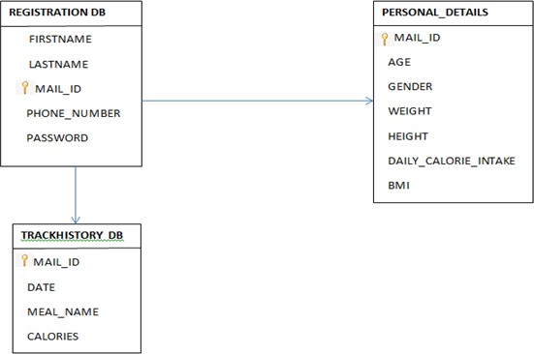

1. **TESTING**

# Test Cases Sprint 2:

|  |  |  |  |
| --- | --- | --- | --- |
| **Test case ID** | **Test Scenario** | **Expected Result** | **Status** |
| Dashboard_TC_OO1 | Verify user is able to see their height, weight, bmi and calorie intake | Verify these are available 1.Height  2.Weight 3.BMI  4.Calorie intake 5.Upload image button 6.Track history button | Pass |
| Dashboard_TC_OO2 | Verify whether upload image button works | Redirected to upload image page | Pass |
| Dashboard_TC_OO3 | Verify whether track history button works | Redirected to History page | Pass |
| Uploadimage_TC_OO1 | Check the choose file option available | Able to view the 1.Choose file 2.Submit button 3.Go back button | Pass |
| Uploadimage_TC_OO2 | Verify whether food image can be uploaded | Preview of the image uploaded will be displayed | Pass |
| Uploadimage_TC_OO3 | Verify whether it alerts when no image is uploaded | The alert will show "Please upload the file" | Pass |
| Trackhistory_TC_OO1 | Verify whether history table displayed | 1.Date picker text box 2.Food name text box 3.Calorie text box 4.Add button  5.The track history table with date,food name and calorie value | Pass |
| Trackhistory_TC_OO2 | Verify whether add button works | 1.Chose Date 2.Enter food 3.Enter Calorie 4.Click add button  5.The data will be added to the table  displayed | Pass |

# Sprint 3:

|  |  |  |  |
| --- | --- | --- | --- |
| **Test case ID** | **Test Scenario** | **Expected Result** | **Status** |
| Registrationdatabase_TC_OO1 | Verify whether registration credentials are added to the cloud database | The given credentials by the user should be same as the credentials stored in ibm cloud database | Pass |
| Personaldetailsdatabase_TC_OO1 | Verify whether personal details credentials are added to the cloud database | The given credentials by the user should be same as the credentials stored in ibm cloud database | Pass |
| Track_historydatabase_TC_OO1 | Verify whether added food details are added to the cloud database | The added food details by the user should be same as the details stored in ibm cloud database | Pass |
| Trackhistory_TC_OO2 | Verify whether add button works | 1.Chose Date 2.Enter food 3.Enter Calorie 4.Click add button  5.The data will be added to the table displayed | Pass |

# User Acceptance Testing

**Sprint 2:**

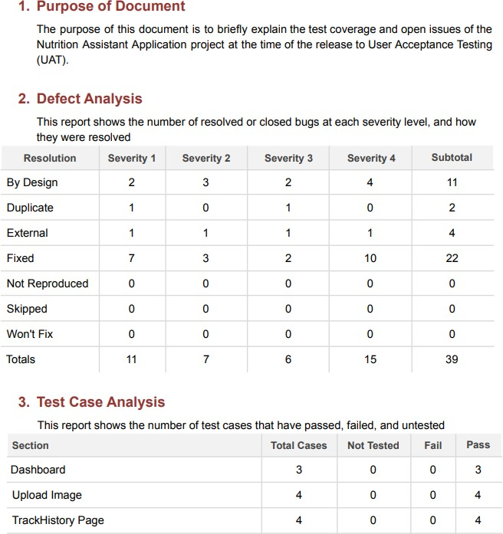

# Sprint 3:

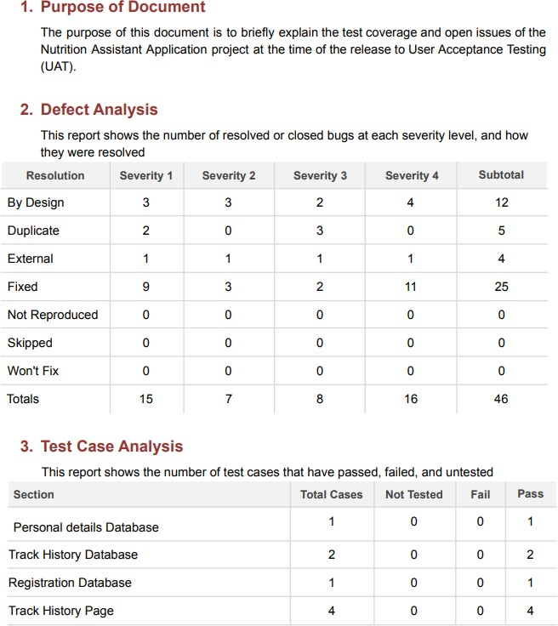

**Sprint 4:**

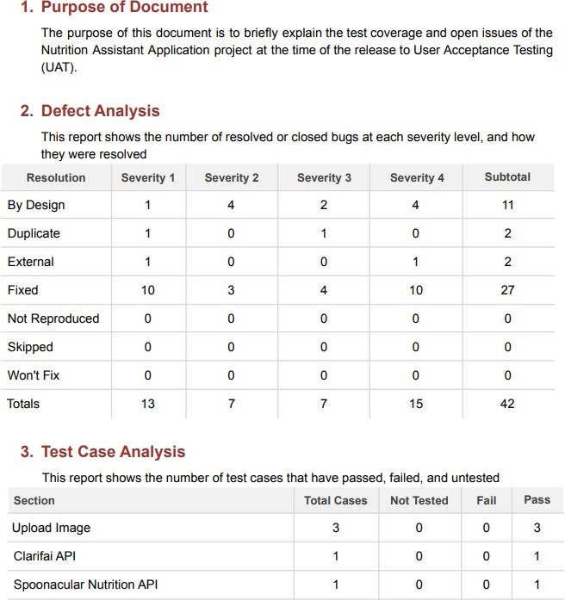

# RESULTS

* 1. **Performance Metrics**

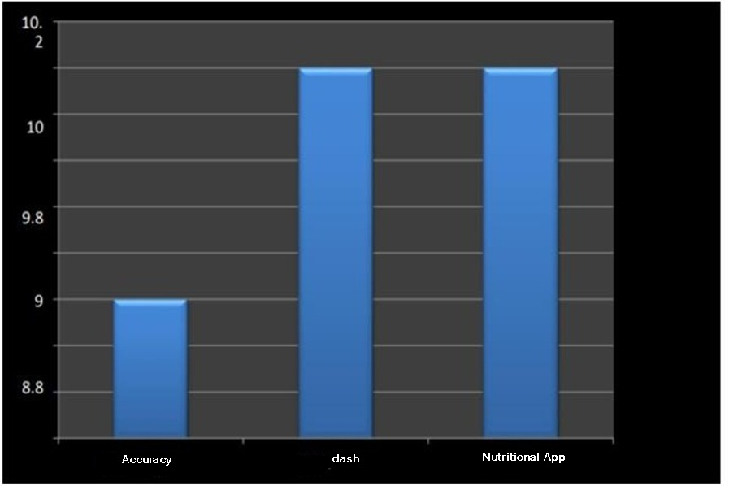

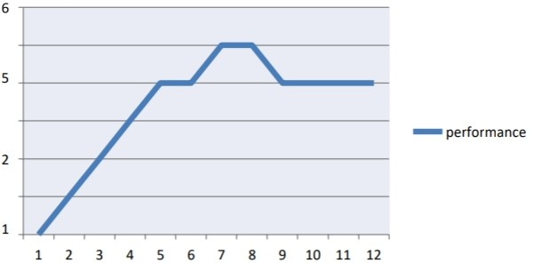

# ADVANTAGES & DISADVANTAGES

**Advantages:**

* + - By using our webapp, the user can know their BMI, which will lead the user to decide whether he has to gain weight or lose weight
    - User can know their daily calorie intake, which can help them to know amount of calorie they can consume for that particular day.
    - The user can upload the image of the meal which will provide them the nutritional value of that particular meal.
    - Nutrition Application is a user friendly and easy to use application.
    - The user can track the daily calorie intake which will help them to know their progress towards their fitness goal.

# Disadvantages:

* + - It requires an active internet connection.
    - Not all types of foods can be detected correctly by Clarifai Food Detection Model API.
    - The user cannot update their personal details once it has been registered.

# CONCLUSION

Since obesity rate has become a major problem in this decade, the diet management is very important. The information about the nutritional value of the food that has been printed in the food packages are not convenient to keep track of the daily calorie intake. Nutrition Application helps in finding the nutritional content present in the food with real time image processing using Clarifai Food Detection Model API and Spoonacular Nutrition API. The user can upload his daily meal image and get the nutritional value. They can also track their daily calorie intake.

# FUTURE SCOPE

Nutrition Application will be upgraded in the following years with the feature of “Profile Updation”. The user can update his personal details like height, weight and age which will help them to keep track of the daily calorie intake and the BMI. “Dietary Recommendation” facility and “Water Reminder” facility will also be added in the future.

# APPENDIX

**Source Code nutritionapp.py :**

from flask import Flask,render_template,request,url_for,redirect,session import ibm_db

import os

from sendgrid import SendGridAPIClient from sendgrid.helpers.mail import Mail import requests

app=Flask( name ) app.secret_key='a'

try:

conn=ibm_db.connect("DATABASE=bludb;HOSTNAME=ba99a9e6-d59e-4883-8fc0- d6a8c9f7a08f.c1ogj3sd0tgtu0lqde00.databases.appdomain.cloud;PORT=31321;SECURITY=SS L;SSLServerCertificate=DigiCertGlobalRootCA.crt;UID=gkr16989;PWD=WvN7xr79Kp6YfdL 7","","")

except:

print("Unable to connect: ",ibm_db.conn_error()) @app.route("/")

def home(): session['status_msg']=' '

return render_template('Home.html') @app.route("/reg")

def reg():

return render_template('Registration.html') @app.route("/register",methods=["POST","GET"]) def register():

if request.method == 'POST' :

firstName = request.form['firstName'] lastName = request.form['lastName'] session['email'] = request.form['email'] phoneNumber = request.form['phoneNumber'] password = request.form['password']

sql = "SELECT * FROM registration WHERE EMAIL_ID=?" stmt = ibm_db.prepare(conn, sql) ibm_db.bind_param(stmt,1,session['email']) ibm_db.execute(stmt)

account = ibm_db.fetch_assoc(stmt) print(account)

message =

Mail(from_email='nutriaux04@gmail.com',to_emails=session['email'],subject="NutriAux - Registration",html_content='<b>NutriAux welcomes you</b><br/><p>Your account has been registered successfully</p>')

try:

sg=SendGridAPIClient('#Use the API key Given in this link for security purpose - [https://docs.google.com/document/d/1xrF_chjAgbNJOCcsrGuVXtKWexPb5Ff5v](https://docs.google.com/document/d/1xrF_chjAgbNJOCcsrGuVXtKWexPb5Ff5vmLpkscbgbU/edit?usp=sharing) [mLpkscbgbU/edit?usp=sharing](https://docs.google.com/document/d/1xrF_chjAgbNJOCcsrGuVXtKWexPb5Ff5vmLpkscbgbU/edit?usp=sharing) ’)

response=sg.send(message) print(response.status_code) print(response.body) print(response.headers)

except Exception as e: print(e)

if account:

session['status_msg']= 'Account already exists ! Kindly login' return redirect(url_for('login'))

else :

insert_sql = "INSERT INTO registration VALUES (?,?,?,?,?)" prep_stmt = ibm_db.prepare(conn, insert_sql) ibm_db.bind_param(prep_stmt, 1, firstName)

ibm_db.bind_param(prep_stmt, 2, lastName)

ibm_db.bind_param(prep_stmt, 3, session['email'])

ibm_db.bind_param(prep_stmt, 4, phoneNumber)

ibm_db.bind_param(prep_stmt, 5, password) ibm_db.execute(prep_stmt)

print('You have successfully registered !') return redirect(url_for('personaldetails'))

@app.route("/personaldetails") def personaldetails():

return render_template("personaldetails.html")

@app.route("/addpersonaldetails",methods=["POST","GET"]) def addpersonaldetails():

if request.method == 'POST' : age=float(request.form.get('age')) gender=request.form.get('Gender') weight=float(request.form.get('weight')) height=float(request.form.get('height')) activity=request.form.get('activity') print(age,gender,weight,height,activity) if(gender == 'male'and activity == "1"):

totalCalories = 1.2 * (66.5 + (13.75 * weight) + (5.003 * height) - (6.755 * age)) elif(gender == 'male' and activity == "2"):

totalCalories = 1.375 * (66.5 + (13.75 * weight) + (5.003 * height) - (6.755 * age)) elif (gender == 'male' and activity == "3"):

totalCalories = 1.55 * (66.5 + (13.75 * weight) + (5.003 * height) - (6.755 * age)) elif(gender == 'male' and activity == "4"):

totalCalories = 1.725 * (66.5 + (13.75 * weight) + (5.003 * height) - (6.755 * age)) elif(gender == 'male' and activity == "5"):

totalCalories = 1.9 * (66.5 + (13.75 * weight) + (5.003 * height) - (6.755 * age)) elif(gender == 'female' and activity == "1"):

totalCalories = 1.2 * (655 + (9.563 * weight) + (1.850 * height) - (4.676 * age)) elif(gender == 'female' and activity == "2"):

totalCalories = 1.375 * (655 + (9.563 * weight) + (1.850 * height) - (4.676 * age)) elif(gender == 'female' and activity == "3"):

totalCalories = 1.55 * (655 + (9.563 * weight) + (1.850 * height) - (4.676 * age)) elif(gender == 'female' and activity == "4"):

totalCalories = 1.725* (655 + (9.563 * weight) + (1.850 * height) - (4.676 * age)) else:

totalCalories = 1.9 * (655 + (9.563 * weight) + (1.850 * height) - (4.676 * age)) print(int(totalCalories))

BMI = (weight / (height/100)**2 ) if BMI <= 18.5:

BMI_message="underweight" elif BMI <= 24.9:

BMI_message="healthy" elif BMI <= 29.9:

BMI_message="overweight" else:

BMI_message="obese" print(BMI)

insert_query="INSERT INTO personal_details VALUES(?,?,?,?,?,?,?)" prep_stmt=ibm_db.prepare(conn,insert_query) ibm_db.bind_param(prep_stmt,1,session['email']) ibm_db.bind_param(prep_stmt,2,str(int(age))) ibm_db.bind_param(prep_stmt,3,gender)

ibm_db.bind_param(prep_stmt,4,str(weight)) ibm_db.bind_param(prep_stmt,5,str(height)) ibm_db.bind_param(prep_stmt,6,str(totalCalories)) ibm_db.bind_param(prep_stmt,7,str(BMI)) ibm_db.execute(prep_stmt)

return redirect(url_for('login')) @app.route("/login")

def login():

return render_template("login.html",message=session['status_msg']) @app.route("/verify",methods=["POST","GET"])

def verify():

session['email'] = request.form.get("email") password = request.form.get("password")

get_query="SELECT * FROM registration WHERE EMAIL_ID=? AND PASSWORD=?" prep=ibm_db.prepare(conn,get_query)

ibm_db.bind_param(prep,1,session['email']) ibm_db.bind_param(prep,2,password) result=ibm_db.execute(prep)

login = ibm_db.fetch_assoc(prep) if login:

get_query="SELECT weight,height,daily_calorie_intake,BMI FROM personal_details WHERE EMAIL_ID=?"

prep=ibm_db.prepare(conn,get_query) ibm_db.bind_param(prep,1,session['email']) result=ibm_db.execute(prep)

data = ibm_db.fetch_tuple(prep) global weight

weight= data[0] global height height= data[1]

global daily_calorie_intake

daily_calorie_intake=data[2] daily_calorie_intake=daily_calorie_intake[0:7] global BMI

BMI=data[3] BMI=BMI[0:4]

return redirect((url_for('dashboard'))) print("Wrong password" , session['email'],password)

return render_template("login.html",message="Incorrect Email ID or Password! Try again") @app.route("/dashboard")

def dashboard(): return

render_template('dashboard.html',weight=weight,height=height,daily_calorie_intake=daily_calor ie_intake,BMI=BMI)

@app.route("/upload") def upload():

return render_template('upload.html',calories="",fat="",protein="",carbs="") @app.route("/history")

def history():

get_query="SELECT CHAR(DATE_OF_CONSUMPTION,EUR)AS DATE,MEAL_NAME,CALORIES FROM TRACKHISTORY WHERE EMAIL_ID=?"

prep=ibm_db.prepare(conn,get_query) ibm_db.bind_param(prep,1,session['email']) result=ibm_db.execute(prep)

if result==False: print("not working")

history=[]

dictionary = ibm_db.fetch_assoc(prep) while dictionary != False:

history.insert(0,dictionary["DATE"]) history.insert(1,dictionary["MEAL_NAME"]) history.insert(2,dictionary["CALORIES"])

print("The date is : ", dictionary["DATE"]) print("The name is : ", dictionary["MEAL_NAME"]) print("The calories is : ", dictionary["CALORIES"]) dictionary = ibm_db.fetch_assoc(prep)

print(history) no_of_rows=len(history)//3 print(no_of_rows)

return render_template("History.html",history=history,no_of_rows=no_of_rows) @app.route("/addhistory",methods=["POST","GET"])

def addhistory():

if request.method=='POST': date=request.form['date'] meal_name=request.form['meal_name'] calories=request.form['calories']

insert_query="INSERT INTO trackhistory VALUES(?,?,?,?)" prep_stmt=ibm_db.prepare(conn,insert_query) ibm_db.bind_param(prep_stmt,1,session['email']) ibm_db.bind_param(prep_stmt,2,date) ibm_db.bind_param(prep_stmt,3,meal_name) ibm_db.bind_param(prep_stmt,4,calories) ibm_db.execute(prep_stmt)

return redirect(url_for('history')) @app.route("/support")

def support():

return render_template("support.html") if name == ' main ':

app.run(debug=True)

# Home.html

<!DOCTYPE html>

<html lang="en">

<head>

<meta charset="UTF-8" />

<meta http-equiv="X-UA-Compatible" content="IE=edge" />

<meta name="viewport" content="width=device-width, initial-scale=1.0" />

<link rel="stylesheet"

href="{{url_for('static',filename='home-style.css')}}"

/>

<title>HOME</title>

<script src="https://kit.fontawesome.com/a076d05399.js"></script>

</head>

<body>

<header>

<img class="logo"

src="{{url_for('static',filename='NutriAux.png')}}" alt="logo"

/>

<nav>

<input type="checkbox" id="check" />

<label for="check" class="checkbtn">

<i class="fas fa-bars"></i>

</label>

<label class="nutri">NutriAux</label>

<ul>

<li><a href="{{url_for('reg')}}">Register</a></li>

<li><a href="{{url_for('login')}}">Login</a></li>

<li><a href="{{url_for('support')}}">Support</a></li>

</ul>

</nav>

</header>

<div class="bg-text">

<p>

<span>NutriAux</span> is a web app that aims at automatically estimating the food attributes such as ingredients and nutritional value by

classifing the input image of the food. The person who wishes to use the app must register before using the app. The user can login to their account to see thier respective dashboard with the details of height, weight, BMI that is automatically generated and the amount of calorie that can be taken according to the BMI of the user. The user can upload the image of the food that he has taken. The app will then display the nutritional value of the food. The user can take a note of it and can

alter his food habits accoring to his BMI and amount of calories that can be intaken. The user can view the history of the food and the calorie intake details in the histroy page. The user can make use of the support in case of any queries.

</p>

</div>

<section></section>

</body>

</html>

# home-style.css

* {

padding: 0;

margin: 0;

text-decoration: none; list-style: none;

font-family: verdana; box-sizing: border-box;

}

body {

background-color: #fdc100;

}

span {

font-size: 30px; text-align: center; font-weight: bold;

}

img.logo { height: 60px; width: 80px; margin: 10px;

}

header { display: flex;

justify-content: space-between; align-items: center;

}

nav {

background-color: #fdc100; height: 80px;

width: 100%;

}

label.nutri { padding: 0 30px; color: black; font-size: 25px;

line-height: 80px; font-weight: bold;

}

nav ul {

float: right;

margin-right: 20px;

}

nav ul li {

display: inline-block; line-height: 80px; margin: 0 5px;

}

nav ul li a { color: black; font-size: 17px;

border: 1px solid transparent; padding: 7px 13px;

border-radius: 3px;

}

a.active, a:hover {

background: #80cc66; border: 1px solid white; transition: 0.5s;

}

.checkbtn {

font-size: 30px; color: crimson; float: right;

line-height: 80px; margin-right: 40px; cursor: pointer; display: none;

}

#check {

display: none;

}

.bg-text {

background-color: rgb(0, 0, 0); /* Fallback color */

background-color: rgba(0, 0, 0, 0.7); /* Black w/opacity/see-through */ color: white;

border: 3px solid #f1f1f1; position: absolute;

top: 50%;

left: 50%;

transform: translate(-50%, -50%);

z-index: 2;

width: 80%; padding: 10px; text-align: justify; font-size: 22px;

}

@media (max-width: 992px) { label.nutri {

font-size: 30px; padding-left: 50px;

}

nav ul li a {

font-size: 16px;

}

.bg-text {

margin-top: 50px; top: 50%;

left: 50%;

}

}

@media (max-width: 858px) {

.checkbtn { display: block;

}

label.nutri { display: none;

}

.bg-text {

font-size: 15px; top: 50%;

left: 50%;

}

ul {

position: fixed; width: 100%; height: 100vh;

background: #ffee99; z-index: 20;

top: 80px; left: -100%;

text-align: center; transition: all 0.5s;

}

nav ul li { display: block; margin: 50px 0;

line-height: 30px;

}

nav ul li a {

font-size: 20px;

color: black;

}

a.active, a:hover {

background: none; border: none; color: #f26d1b;

}

#check:checked ~ ul { left: 0;

}

}

section { width: 100%;

background: url(food2.jpg); background-position: center; background-size: cover; height: calc(100vh - 80px); background-repeat: no-repeat;

}

# Registration.html

<!DOCTYPE html>

<html>

<head>

<meta charset="utf-8" />

<title>Responsive Registration Form</title>

<meta name="viewport"

content="width=device-width, initial-scale=1.0"

/>

<link rel="stylesheet"

href="{{url_for('static',filename='Registration-style.css')}}"

/>

</head>

<body>

<div class="container">

<h1 class="form-title">

<img class="logo"

src="{{url_for('static',filename='NutriAux.png')}}" alt="logo"

/>&emsp;Registration

</h1>

<form action="/register" method="post">

<div class="main-user-info">

<div class="user-input-box">

<label for="firstName">First Name</label>

<input type="text" id="firstName"

name="firstName" placeholder="Enter First Name" required

/>

</div>

<div class="user-input-box">

<label for="lastName">Last Name</label>

<input type="text"

id="lastName" name="lastName" placeholder="Enter Last Name" required

/>

</div>

<div class="user-input-box">

<label for="email">Email</label>

<input type="email" id="email" name="email"

placeholder="Enter Email" required

/>

</div>

<div class="user-input-box">

<label for="phoneNumber">Phone Number</label>

<input type="text"

id="phoneNumber" name="phoneNumber" placeholder="Enter Phone Number" required

/>

</div>

<div class="user-input-box">

<label for="password">Password</label>

<input type="password" id="password"

name="password" placeholder="Enter Password"

pattern="^(?=.*[A-Za-z])(?=.*\d)[A-Za-z\d]{5,}$" required

/>

</div>

<div class="user-input-box">

<label for="confirmPassword">Confirm Password</label>

<input type="password" id="confirmPassword"

name="confirmPassword" placeholder="Confirm Password"

pattern="^(?=.*[A-Za-z])(?=.*\d)[A-Za-z\d]{5,}$" required

/>

</div>

<div>

<span style="color: white; font-size: 13px"

>Password must be minimum Five characters with at least one letter and one number</span

>

</div>

</div>

<div class="form-submit-btn">

<input type="submit" value="Register" />

</div>

<div class="go-back-btn">

<a href="Home.html" class="goback">Go Back</a>

</div>

</form>

</div>

</body>

</html>

# Registration-style.css

@import url(["https://fonts.googl](https://fonts.googleapis.com/css2?family=Poppins%3Awght%40200%3B300%3B400%3B500%3B600%3B700&di)e[apis.com/css2?family=Poppins:wght@200;300;400;500;600;700&di](https://fonts.googleapis.com/css2?family=Poppins%3Awght%40200%3B300%3B400%3B500%3B600%3B700&di) splay=swap");

* {

padding: 0;

margin: 0;

box-sizing: border-box;

font-family: "Poppins", sans-serif;

}

img.logo { height: 60px; width: 70px; margin: 10px;

}

body { display: flex;

height: 100vh;

justify-content: center; align-items: center;

background-color: #f1f375d7;

background-image: url("calorie_calc_bg.png"); background-blend-mode: color-burn; background-size: 430px 400px;

/*background: linear-gradient(to bottom right, #f9d423 0%, #ff4e50 100%);}*/

}

.container { width: 100%;

max-width: 650px; background: rgba( 0,

0,

0,

0.6

); /*fdc100 - 253,193,0 06837f - 6,131,127 b4ffff - 180,255,255 02cecb - 2,206,203*/

padding: 28px; margin: 0 28px; border-radius: 10px;

box-shadow: inset -2px 2px 2px white;

}

.form-title {

font-size: 26px; font-weight: 600; text-align: center;

padding-bottom: 6px; color: white;

border-bottom: solid 1px white; display: flex;

align-items: center;

}

.main-user-info { display: flex; flex-wrap: wrap;

justify-content: space-between; padding: 15px 0;

}

.user-input-box:nth-child(2n) { justify-content: end;

}

.user-input-box { display: flex; flex-wrap: wrap; width: 50%;

padding-bottom: 12px;

}

.user-input-box label { width: 95%;

color: white; font-size: 20px;

font-weight: 400;

margin: 5px 0;

}

.user-input-box input { height: 30px;

width: 95%; border-radius: 5px; outline: none;

border: 1px solid grey; padding: 0 10px;

}

.gender-title {

color: white; font-size: 20px;

font-weight: 400;

}

.gender-category { margin: 20px 0; color: white;

}

.gender-category label { padding: 0 20px 0 2px;

}

.gender-category label,

.gender-category input,

.form-submit-btn input { cursor: pointer;

}

.form-submit-btn { margin-top: 20px;

}

.form-submit-btn input { display: block;

width: 100%; margin-top: 10px; font-size: 20px; padding: 7px; border: none;

border-radius: 3px;

color: rgb(255, 255, 255);

background: rgba(253, 193, 0, 0.7);

}

.form-submit-btn input:hover { background: rgba(2, 206, 203, 0.7);

color: rgb(255, 255, 255);

}

.go-back-btn { margin-top: 20px;

}

.go-back-btn a { display: block; width: 100%; margin-top: 10px; font-size: 20px; padding: 7px;

text-decoration: none; border: none;

text-align: center; border-radius: 3px;

color: rgb(255, 255, 255);

background: rgba(253, 193, 0, 0.7);

}

.go-back-btn a:hover {

background: rgba(2, 206, 203, 0.7);

color: rgb(255, 255, 255); cursor: pointer;

}

@media (max-width: 600px) {

.container {

min-width: 280px;

}

.user-input-box { margin-bottom: 12px; width: 100%;

}

.user-input-box:nth-child(2n) { justify-content: space-between;

}

.gender-category { display: flex;

justify-content: space-between; width: 100%;

font-size: 17px;

}

.main-user-info { max-height: 380px; overflow: auto;

}

.main-user-info::-webkit-scrollbar { width: 0;

}

}

# personaldetails.html:

<!DOCTYPE html>

<html lang="en">

<head>

<!-- Required meta tags -->

<meta charset="utf-8" />

<meta name="viewport"

content="width=device-width, initial-scale=1, shrink-to-fit=no"

/>

<!-- Bootstrap CSS -->

<link rel="stylesheet"

href="https://stackpath.bootstrapcdn.com/bootstrap/4.5.2/css/bootstrap.min.css" integrity="sha384-

JcKb8q3iqJ61gNV9KGb8thSsNjpSL0n8PARn9HuZOnIxN0hoP+VmmDGMN5t9UJ0Z" crossorigin="anonymous"

/>

<title>Calorie Calculator</title>

<style> body {

background-color: #f1f375d7;

background-image: url("{{url_for('static',filename='calorie_calc_bg.png')}}"); background-blend-mode: color-burn;

background-size: 430px 400px;

}

.results { display: none;

}

.btn {

background: lighten(#06837f, 3%);

font-weight: 600; letter-spacing: 1px;

}

</style>

</head>

<body>

<div class="container">

<div class="row">

<div class="col-lg-7 mx-auto">

<div class="card card-body text-center mt-5">

<h3 class="heading display-5 pb-3 mb-4"> Enter your personal details

</h3>

<form id="calorie-form" method="post" action="/addpersonaldetails">

<div class="form-group row">

<label for="age" class="col-sm-2 col-form-label">Age</label>

<div class="col-sm-10">

<input type="text"

class="form-control" id="age" name="age"

placeholder="Age > 17"

pattern="(?:1[01][0-9]|120|1[7-9]|[2-9][0-9])$"

required

/>

</div>

</div>

<fieldset class="form-group">

<div class="row">

<legend class="col-form-label col-sm-2 pt-0">Gender</legend>

<div class="col-sm-10" id="form-radio">

<div

class="custom-control custom-radio custom-control-inline"

>

<input type="radio" id="male" name="Gender" value="male"

class="custom-control-input" checked="checked"

/>

<label class="custom-control-label" for="male"

>Male</label

>

</div>

<div

class="custom-control custom-radio custom-control-inline"

>

<input type="radio" id="female" name="Gender" value="female"

class="custom-control-input"

/>

<label class="custom-control-label" for="female"

>Female</label

>

</div>

</div>

</div>

</fieldset>

<div class="form-group row">

<label for="weight" class="col-sm-2 col-form-label"

>Weight</label

>

<div class="col-sm-10">

<input type="number" class="form-control" id="weight" name="weight"

placeholder="In kilograms" required

/>

</div>

</div>

<div class="form-group row">

<label for="height" class="col-sm-2 col-form-label"

>Height</label

>

<div class="col-sm-10">

<input type="number" class="form-control" id="height" name="height"

placeholder="In centimeters" required

/>

</div>

</div>

<div class="form-group row">

<legend class="col-form-label col-sm-2 pt-0">Activity</legend>

<select

class="custom-select col-sm-10 col-lg-9 ml-3" id="list"

name="activity"

>

<option selected value="1"> Sedentary (little or no exercise)

</option>

<option value="2">

Lightly active (light exercise/sports 1-3 days/week)

</option>

<option value="3">

Moderately active (moderate exercise/sports 3-5 days/week)

</option>

<option value="4">

Very active (hard exercise/sports 6-7 days a week)

</option>

<option value="5">

Extra active (very hard exercise/sports & physical job or 2x training)

</option>

</select>

</div>

<div class="form-group" style="margin-top: 70px">

<input type="submit"

value="Proceed to dashboard" class="btn btn-block"

style="background-color: #06837f; color: white"

/>

<input type="button"

onclick="window.history.back()" value="Go Back"

class="btn btn-block"

style="background-color: #06837f; color: white"

/>

</div>

</form>

</div>

</div>

</div>

</div>

<script

src="https://code.jquery.com/jquery-3.5.1.slim.min.js" integrity="sha384-

DfXdz2htPH0lsSSs5nCTpuj/zy4C+OGpamoFVy38MVBnE+IbbVYUew+OrCXaRkfj"

crossorigin="anonymous"

></script>

<script src=["https://](https://cdn.jsdelivr.net/npm/popper.js%401.16.1/dist/umd/popper.min.js)c[dn.jsdelivr.net/npm/popper.js@1.16.1/dist/umd/popper.min.js"](https://cdn.jsdelivr.net/npm/popper.js%401.16.1/dist/umd/popper.min.js) integrity="sha384-

9/reFTGAW83EW2RDu2S0VKaIzap3H66lZH81PoYlFhbGU+6BZp6G7niu735Sk7lN"

crossorigin="anonymous"

></script>

<script src="https://stackpath.bootstrapcdn.com/bootstrap/4.5.2/js/bootstrap.min.js" integrity="sha384-

B4gt1jrGC7Jh4AgTPSdUtOBvfO8shuf57BaghqFfPlYxofvL8/KUEfYiJOMMV+rV" crossorigin="anonymous"

></script>

</body>

</html>

# Login.html

<! DOCTYPE html>

<html lang="en">

<head>

<meta charset="UTF-8" />

<title>Login Form</title>

<link rel="stylesheet"

href="https://stackpath.bootstrapcdn.com/bootstrap/4.1.3/css/bootstrap.min.css"

/>

</head>

<style> body {

padding-top: 50px;

background-color: #f1f375d7;

background-image: url("{{url_for('static',filename='calorie_calc_bg.png')}}"); background-blend-mode: color-burn;

background-size: 430px 400px;

}

.login-form { background: #dcf1f1; margin-top: 40px; margin-bottom: 100px; padding: 50px;

border-radius: 50px;

box-shadow: 10px 10px 5px 0px rgba(0, 0, 0, 0.75);

}

.btn-primary { width: 100%;

}

</style>

<body>

<div class="container">

<div class="row">

<div class="col-md-8 offset-md-2">

<div class="login-form">

<h1 class="text-center" style="padding-bottom: 30px">Login Form</h1>

<form action="/verify" method="post">

<div class="form-group">

<label for="exampleInputEmail1">Enter Email address </label>

<input type="email" name="email"

class="form-control" id="exampleInputEmail1" aria-describedby="emailHelp" placeholder="Enter email" required

/>

<small id="emailHelp" class="form-text text-muted"> We'll never share your email with anyone else.

</small>

</div>

<div class="form-group">

<label for="exampleInputPassword1"> Enter Password </label>

<input type="password" class="form-control" id="password" name="password"

placeholder="Password"

pattern="^(?=.*[A-Za-z])(?=.*\d)[A-Za-z\d]{5,}$" required

/>

</div>

<div class="form-group form-check">

<input type="checkbox"

class="form-check-input" onclick="showpass()"

/>

<label class="form-check-label" for="exampleCheck1"> Show Password

</label>

</div>

<span style="color: red">{{message}}</span>

<button type="submit"

class="btn btn-primary" style="margin-top: 10px"

>

Submit

</button>

</form>

</div>

</div>

</div>

</div>

<script>

function showpass() {

var x = document.getElementById("password"); if (x.type === "password") {

x.type = "text";

} else {

x.type = "password";

}

}

</script>

<script

src="https://code.jquery.com/jquery-3.3.1.slim.min.js" integrity="sha384-

q8i/X+965DzO0rT7abK41JStQIAqVgRVzpbzo5smXKp4YfRvH+8abtTE1Pi6jizo" crossorigin="anonymous"

></script>

<script

src="https://cdnjs.cloudflare.com/ajax/libs/popper.js/1.14.7/umd/popper.min.js" integrity="sha384-

UO2eT0CpHqdSJQ6hJty5KVphtPhzWj9WO1clHTMGa3JDZwrnQq4sF86dIHNDz0W1" crossorigin="anonymous"

></script>

<script src="https://stackpath.bootstrapcdn.com/bootstrap/4.3.1/js/bootstrap.min.js" integrity="sha384-

JjSmVgyd0p3pXB1rRibZUAYoIIy6OrQ6VrjIEaFf/nJGzIxFDsf4x0xIM+B07jRM" crossorigin="anonymous"

></script>

<script></script>

</body>

</html>

# dashboard.html

<!DOCTYPE html>

<html>

<head>

<title>

Dashboard

</title>

<meta name="viewport" content="width=device-width , initial-scale=1.0">

<link rel="stylesheet"

href=["https://](https://cdn.jsdelivr.net/npm/bootstrap%404.6.1/dist/css/bootstrap.min.css)c[dn.jsdelivr.net/npm/bootstrap@4.6.1/dist/css/bootstrap.min.css"](https://cdn.jsdelivr.net/npm/bootstrap%404.6.1/dist/css/bootstrap.min.css)>

<script src=["https://](https://cdn.jsdelivr.net/npm/jquery%403.6.0/dist/jquery.slim.min.js)c[dn.jsdelivr.net/npm/jquery@3.6.0/dist/jquery.slim.min.js](https://cdn.jsdelivr.net/npm/jquery%403.6.0/dist/jquery.slim.min.js)"></script>

<script src=["https://](https://cdn.jsdelivr.net/npm/popper.js%401.16.1/dist/umd/popper.min.js)c[dn.jsdelivr.net/npm/popper.js@1.16.1/dist/umd/popper.min.js](https://cdn.jsdelivr.net/npm/popper.js%401.16.1/dist/umd/popper.min.js)"></script>

<link href=["https://cdn.jsdelivr.net/npm/](https://cdn.jsdelivr.net/npm/bootstrap%405.0.2/dist/css/bootstrap.min.css)b[ootstrap@5.0.2/dist/css/bootstrap.min.css"](https://cdn.jsdelivr.net/npm/bootstrap%405.0.2/dist/css/bootstrap.min.css) rel="stylesheet" integrity="sha384-

EVSTQN3/azprG1Anm3QDgpJLIm9Nao0Yz1ztcQTwFspd3yD65VohhpuuCOmLASjC" crossorigin="anonymous">

<script src=["https://](https://cdn.jsdelivr.net/npm/bootstrap%405.2.2/dist/js/bootstrap.bundle.min.js)c[dn.jsdelivr.net/npm/bootstrap@5.2.2/dist/js/bootstrap.bundle.min.js"](https://cdn.jsdelivr.net/npm/bootstrap%405.2.2/dist/js/bootstrap.bundle.min.js) integrity="sha384- OERcA2EqjJCMA+/3y+gxIOqMEjwtxJY7qPCqsdltbNJuaOe923+mo//f6V8Qbsw3" crossorigin="anonymous"></script>

<link rel="stylesheet" href="https://cdnjs.cloudflare.com/ajax/libs/font- awesome/4.7.0/css/font-awesome.min.css">

<link rel="stylesheet" href="{{url_for('static',filename='dashboard.css')}}">

</head>

<body>

<nav class="navbar navbar-expand-lg ">

<div class="container-fluid">

<img class="navbar-brand" src="{{url_for('static',filename='NutriAux.png')}}" alt="NutriAux" height="60px" width="60px" ><h3 style="color: white; margin-left: 30px;margin-top: 15px;">Dashboard</h3>

<button class="navbar-toggler" type="button" data-bs-toggle="collapse" data-bs- target="#navbarNav" aria-controls="navbarNav" aria-expanded="false" aria-label="Toggle navigation">

<i class="fa fa-bars" style="font-size:36px"></i>

</button>

<div class="collapse navbar-collapse" id="navbarNav">

<ul class="navbar-nav ml-auto text-right">

<li class="nav-item">

<a class="nav-link" href="{{url_for('support')}}">Support</a>

</li>

<li class="nav-item ">

<a class="nav-link" href="{{url_for('home')}}">Logout</a>

</li>

</ul>

</div>

</div>

</div>

</nav>

<div class="container">

<div class="row ">

<div class="column border box">

<img src="{{url_for('static',filename='height.jpg')}}" class="rounded-circle" alt="height" id="pic" >

<h4>Height: {{height}} </h4>

</div>

<div class="column border box">

<img src="{{url_for('static',filename='weight.png')}}" class="rounded-circle" alt="weight" id="pic" >

<h4>Weight: {{weight}} </h4>

</div>

</div>

<div class="row my-0 ">

<div class="column border box">

<img src="{{url_for('static',filename='bmi.jpg')}}"class="rounded-circle" alt="bmi" id="pic" >

<h4>BMI: {{BMI}} </h4>

</div>

<div class="column border box">

<img src="{{url_for('static',filename='caloriesintake.png')}}" class="rounded- circle" alt="Calorie" id="pic" >

<h4>Calorie Intake: {{daily_calorie_intake}} </h4>

</div>

</div>

<div class="row">

<div class="column">

<a href="{{url_for('upload')}}" id="bu1" class="btn btn-info btn-lg">Upload Image</a>

</div>

<div class="column ">

<a href="{{url_for('history')}}" id="bu1" class="btn btn-info btn-lg">Track History</a>

</div>

</div>

</div>

</div>

</div>

</div>

</body>

</html>

# dashboard.css

body{

background-color:#D4F1F4;

}

.nav-item{

text-align: end;

}

.navbar-toggler{

outline: none !important; padding: 0 !important;

}

.navbar-toggler i{ width: 40px;

}

#bu1{

text-decoration: none;

}

.navbar{

background-color:#05445E; top: 0;

width: 100%; overflow: hidden; height: 65px;

}

.nav-link{ color: white;

font-weight: 900; margin-left: 50px; letter-spacing: 2px;

}

.nav-item a:hover{ color: #FDC100;

}

* {

box-sizing: border-box;

}

.row { display: flex;

margin-top: 30px; margin-bottom: 15px;

}

.box{

background-color: #a0dfdf;

}

.container{

margin: 50px auto; width:40%;

text-align: center;

}

.container h3{ color: #272643;

}

.container img{ object-fit:contain;

}

.column { flex: 33.33%; padding: 5px;

margin-right:15px;

}

#pic{

height: 100px; width: 130px;

}

#img{

background-color: #24a0ed; color: black;

padding: 14px 25px; text-align: center; text-decoration: none; display: inline-block;

}

#bu1{

background-color:#05445E ; color: white;

font-weight: 800; font-size: medium; border-style: none; text-align:center;

}

# upload.html:

<!DOCTYPE html>

<html>

<head>

<title>Upload image</title>

<link href=["https://cdn.jsdelivr.net/npm/](https://cdn.jsdelivr.net/npm/bootstrap%405.0.2/dist/css/bootstrap.min.css)b[ootstrap@5.0.2/dist/css/bootstrap.min.css"](https://cdn.jsdelivr.net/npm/bootstrap%405.0.2/dist/css/bootstrap.min.css) rel="stylesheet" integrity="sha384-

EVSTQN3/azprG1Anm3QDgpJLIm9Nao0Yz1ztcQTwFspd3yD65VohhpuuCOmLASjC" crossorigin="anonymous">

<link rel="stylesheet" href="https://cdnjs.cloudflare.com/ajax/libs/font- awesome/4.7.0/css/font-awesome.min.css">

<link rel="stylesheet" href="{{url_for('static',filename='upload.css')}}">

</head>

<body>

<script src=["https://](https://cdn.jsdelivr.net/npm/bootstrap%405.2.2/dist/js/bootstrap.bundle.min.js)c[dn.jsdelivr.net/npm/bootstrap@5.2.2/dist/js/bootstrap.bundle.min.js"](https://cdn.jsdelivr.net/npm/bootstrap%405.2.2/dist/js/bootstrap.bundle.min.js) integrity="sha384- OERcA2EqjJCMA+/3y+gxIOqMEjwtxJY7qPCqsdltbNJuaOe923+mo//f6V8Qbsw3" crossorigin="anonymous"></script>

<form action="/getnutri" method="post" enctype="multipart/form-data">

<div class="container uploadOuter ">

<table class="uploadimage">

<tr>

<th><label for="uploadFile" id="file" ><h2>Choose your image to upload</h2><i class="fa fa-file-photo-o" style="font-size:48px;color:red"></i></i>

</label></th>

<th> </th>

<th><h3>OR</h3></th>

<th><span class="dragBox" >

<h2>Drag and Drop image here</h2><i class="fa fa-file-photo-o" style="font- size:48px;color:red"></i>

<input name="file" type="file" onChange="dragNdrop(event)" ondragover="drag()" ondrop="drop()" id="uploadFile" required/>

</span></th>

</tr>

</table>

<button class="btn btn-primary btn-lg" id="b1" onclick="window.history.back()">Go Back </button>

<button class="btn btn-primary btn-lg" id="b1" type="submit" >Submit </button>

</div>

</form>

</div>

</div>

<div>

<table class="table table-bordered"><br/><br/>

<tr>

<th scope="col" style="background-color:#050a30;color:white;">Calories</th>

<td style="background-color:white;">{{calories}}</td>

</tr>

<tr>

<th scope="col" style="background-color:#050a30;color:white;">Protein</th>

<td style="background-color:white;">{{protein}}</td>

</tr>

<tr>

<th scope="col" style="background-color:#050a30;color:white;">Fat</th>

<td style="background-color:white;">{{fat}}</td>

</tr>

<tr>

<th scope="col" style="background-color:#050a30;color:white;">Carbs</th>

<td style="background-color:white;">{{carbs}}</td>

</tr>

</table>

</div>

<div id="preview" style="height:105px"> </div>

</div>

</div>

<script> "use strict";

function dragNdrop(event) {

var fileName = URL.createObjectURL(event.target.files[0]); var preview = document.getElementById("preview");

var previewImg = document.createElement("img"); previewImg.setAttribute("src", fileName); previewImg.setAttribute("width", "100px"); previewImg.setAttribute("height", "100px");

preview.innerHTML = ""; preview.appendChild(previewImg);

}

function drag() {

document.getElementById('uploadFile').parentNode.className = 'draging dragBox';

}

function drop() { document.getElementById('uploadFile').parentNode.className = 'dragBox';

}

</script>

</body>

</html>

# upload.css:

body {

background-image: url("calorie_calc_bg.png"); background-color: #f1f375d7;

background-blend-mode: color-burn; background-size: 430px 400px;

}

.uploadOuter { text-align: center; padding: 30px;

}

h2,

h3 {

color: #000c66;

}

table { display: flex;

flex-direction: row;

justify-content: center; margin: 10px;

margin-bottom: auto; padding: 20px;

}

#file {

padding: 15px; width: 300px; height: 180px; text-align: center;

border: 2px dotted #050a30; border-radius: 7px;

cursor: pointer; position: relative; color: #000c66;

}

.dragBox { padding: 15px; width: 300px; height: 180px;

border-radius: 7px; margin: 0 auto; position: relative; text-align: center; font-weight: bold; line-height: 95px;

border: 2px dotted #050a30; display: inline-block; transition: transform 0.3s;

}

input[type="file"] {

position: absolute; height: 100%;

width: 100%;

opacity: 0;

top: 0;

left: 0;

}

.draging {

transform: scale(1.1);

}

#preview {

text-align: center;

}

img {

max-width: 100%;

}

#b1 {

background-color: #000c66; color: white;

border: none;

}

# History.html:

<!DOCTYPE html>

<html lang="en">

<head>

<meta charset="UTF-8" />

<meta name="viewport" content="width=device-width, initial-scale=1.0" />

<meta http-equiv="X-UA-Compatible" content="ie=edge" />

<title>Track history</title>

<link href=["https://cdn.jsdelivr.net/npm/](https://cdn.jsdelivr.net/npm/bootstrap%405.2.2/dist/css/bootstrap.min.css)b[ootstrap@5.2.2/dist/css/bootstrap.min.css"](https://cdn.jsdelivr.net/npm/bootstrap%405.2.2/dist/css/bootstrap.min.css) rel="stylesheet" integrity="sha384-

Zenh87qX5JnK2Jl0vWa8Ck2rdkQ2Bzep5IDxbcnCeuOxjzrPF/et3URy9Bv1WTRi" crossorigin="anonymous"/>

<!--Navbar fonts-->

<link rel="stylesheet" href=["https://](https://cdn.jsdelivr.net/npm/%40fortawesome/fontawesome-)c[dn.jsdelivr.net/npm/@fortawesome/fontawesome-](https://cdn.jsdelivr.net/npm/%40fortawesome/fontawesome-) free@6.2.0/css/fontawesome.min.css" integrity="sha384- z4tVnCr80ZcL0iufVdGQSUzNvJsKjEtqYZjiQrrYKlpGow+btDHDfQWkFjoaz/Zr" crossorigin="anonymous">

<!--Adding icons-->

<!--Date icon and bootstrap alignment-->

<link rel="stylesheet"

href="https://maxcdn.bootstrapcdn.com/bootstrap/3.4.0/css/bootstrap.min.css"/>

<!--Burger icon-->

<script src='https://kit.fontawesome.com/a076d05399.js' crossorigin='anonymous'></script>

<!--Bolt icon-->

<link rel="stylesheet" href="https://cdnjs.cloudflare.com/ajax/libs/font- awesome/4.7.0/css/font-awesome.min.css">

<!--Nav Icon-->

<script src="https://kit.fontawesome.com/a076d05399.js" crossorigin="anonymous"></script>

<!--Link to trackhistorystyle.css file-->

<link rel="stylesheet" href="{{url_for('static',filename='trackhistorystyle.css')}}"/>

</head>

<body>

<!--Navbar-->

<div class="bg">

<nav>

<img src="{{url_for('static',filename='NutriAux.png')}}" style="width:60px; height:55px;margin-right:15px;margin-bottom: 17px;margin-left:15px;"/>

<input type="checkbox" id="check">

<label for="check" class="checkbtn">

<i class="fas fa-bars"></i>

</label>

<label class="logo"><span style="margin-top:5px;">Track History</span></label>

<ul>

<li>

<button class="navbutton" onclick="window.history.back()" ><a >Go Back</a></button>

</li>

<li>

<a href="#">Upload Image</a>

</li>

<li class="nav-item">

<a href="{{url_for('support')}}">Support</a>

</li>

<li class="nav-item">

<a href="{{url_for('home')}}">Log out</a>

</li>

</ul>

</nav>

<div class="container" style="margin-top: 50px;">

<form action='/addhistory' method="POST">

<div class="row">

<div class="col-md-3 mt-3">

<!--component-->

<span style="font-size:17px;">Date:</span>

<div class="input-group date" id="datePicker" >

<span class="input-group-addon">

<i class="glyphicon glyphicon-calendar" style="color:#0b3c49"></i>

</span>

<input type="text"

class="form-control" name="date" id="date"

readonly

style="background-color:white"

/>

</div>

</div>

<div class="col-md-3 mt-3">

<span style="font-size:17px;">Enter the food name:</span>

<div class="input-group date" id="datePicker" >

<span class="input-group-addon" >

<i class='fas fa-hamburger ' style="color:#0b3c49"></i>

</span>

<input type="text"

class="form-control" name="meal_name" id="meal_name"

/>

</div>

</div>

<div class="col-md-3 mt-3">

<span style="font-size:17px;">Enter Calories:</span>

<div class="input-group date" id="datePicker" >

<span class="input-group-addon">

<i class="fa fa-bolt" style=" color:#0b3c49"></i>

</span>

<input type="text"

class="form-control" name="calories" id="calories"

/>

</div></div>

<div class="col-md-3 mt-3" style="margin-left:auto">

<button type="submit" class="btn btn-default" width="50px" style="margin- top:20px ;background-color:white;color: #0b3c49;border-color: #0b3c49;" ><b>Add

+</b></button>

</div>

</div>

<div class="row">

<div class="col-md-12">

<table class="table table-bordered"><br/><br/>

<thead class="thead" style="background-color:#0b3c49;color:white;" >

<tr>

<th scope="col">Date</th>

<th scope="col">Food Name</th>

<th scope="col">Calories</th>

</tr>

</thead>

<tbody>

{%set count = namespace(value=0)%}

{%for i in range(no_of_rows)%}

<tr>

{%for j in range(3)%}

<td>{{history[count.value]}}{%set count.value = count.value + 1%}</td>

{%endfor%}

</tr>

{%endfor%}

</tbody>

</table>

</div>

</div>

</div>

</form>

</div>

</div>

<!--Link to trackhistory Javascript-->

<script src="{{url_for('static',filename='trackhistory.js')}}"></script>

<!-- jQuery first, then Popper.js, then Bootstrap JS -->

<script src="https://code.jquery.com/jquery-3.2.1.slim.min.js" integrity="sha384- KJ3o2DKtIkvYIK3UENzmM7KCkRr/rE9/Qpg6aAZGJwFDMVNA/GpGFF93hXpG5KkN" crossorigin="anonymous"></script>

<script src=["https://](https://cdn.jsdelivr.net/npm/popper.js%401.12.9/dist/umd/popper.min.js)c[dn.jsdelivr.net/npm/popper.js@1.12.9/dist/umd/popper.min.js"](https://cdn.jsdelivr.net/npm/popper.js%401.12.9/dist/umd/popper.min.js) integrity="sha384- ApNbgh9B+Y1QKtv3Rn7W3mgPxhU9K/ScQsAP7hUibX39j7fakFPskvXusvfa0b4Q" crossorigin="anonymous"></script>

<script src=["https://](https://cdn.jsdelivr.net/npm/bootstrap%404.0.0/dist/js/bootstrap.min.js)c[dn.jsdelivr.net/npm/bootstrap@4.0.0/dist/js/bootstrap.min.js"](https://cdn.jsdelivr.net/npm/bootstrap%404.0.0/dist/js/bootstrap.min.js) integrity="sha384- JZR6Spejh4U02d8jOt6vLEHfe/JQGiRRSQQxSfFWpi1MquVdAyjUar5+76PVCmYl" crossorigin="anonymous"></script>

</body>

</html>

# trackhistorystyle.css:

* {

margin: 0;

padding: 0;

text-decoration: none; list-style: none;

box-sizing: border-box;

}

body {

font-family: montserrat; background: #dcf1f1;

}

.bg {

height: 100vh; width: 100%;

background-image: linear-gradient(#dcf1f16a, #dcf1f16a), url("track_history.png");

}

button.navbutton { background: none; color: white; border: none; padding: 0;

font: inherit; cursor: pointer; outline: inherit;

}

nav {

background: #0b3c49; height: 80px;

width: 100%;

}

label.logo { color: white; font-size: 25px;

line-height: 80px; padding: 0 10px; font-weight: bold;

}

nav ul { float: right;

margin-right: 10px;

}

nav ul li {

display: inline-block; line-height: 80px; margin: 0 5px;

}

nav ul li a { color: white; font-size: 17px;

padding: 7px 13px; border-radius: 3px;

text-transform: uppercase;

}

a:hover { color: white;

background: #02cecb87;

text-decoration: none;

}

.checkbtn {

font-size: 30px; color: white; float: right;

line-height: 80px; margin-right: 40px; cursor: pointer; display: none;

}

#check { display: none;

}

@media (max-width: 952px) { label.logo {

font-size: 25px;

}

nav ul li a {

font-size: 16px;

}

}

@media (max-width: 858px) {

.checkbtn { display: block;

}

ul {

position: fixed; width: 100%; height: 100vh;

background: #07262f;

top: 80px; left: -100%;

text-align: center; z-index: 20; transition: all 0.5s;

}

nav ul li { display: block; margin: 50px;

line-height: 30px;

}

nav ul li a {

font-size: 20px;

}

a:hover { background: none; color: #90f1bab6;

}

button.navbutton:hover { color: #90f1bab6;

}

#check:checked ~ ul { left: 0;

}

}

.container { background: white; margin-top: 30px; margin-bottom: 30px;

border: 1px solid rgba(0, 0, 0, 0.4); padding: 30px;

border-radius: 6px;

}

# trackhistory.js:

var todaydate = new Date(); var day = todaydate.getDate();

var month = todaydate.getMonth() + 1; var year = todaydate.getFullYear();

var datestring = day + "." + month + "." + year; document.getElementById("date").value = datestring;

# support.html:

<!DOCTYPE html>

<html lang="en">

<head>

<meta charset="UTF-8" />

<meta name="viewport" content="width=device-width, initial-scale=1.0" />

<meta http-equiv="X-UA-Compatible" content="ie=edge" />

<title>Support</title>

<!-- CSS only -->

<link href=["https://](https://cdn.jsdelivr.net/npm/bootstrap%405.2.2/dist/css/bootstrap.min.css)c[dn.jsdelivr.net/npm/bootstrap@5.2.2/dist/css/bootstrap.min.css"](https://cdn.jsdelivr.net/npm/bootstrap%405.2.2/dist/css/bootstrap.min.css) rel="stylesheet"

integrity="sha384- Zenh87qX5JnK2Jl0vWa8Ck2rdkQ2Bzep5IDxbcnCeuOxjzrPF/et3URy9Bv1WTRi"

crossorigin="anonymous"

/>

<link rel="stylesheet"

href="https://stackpath.bootstrapcdn.com/font-awesome/4.7.0/css/font-awesome.min.css"

/>

<!-- JavaScript Bundle with Popper Bootstrap -->

<script src=["https://](https://cdn.jsdelivr.net/npm/bootstrap%405.2.2/dist/js/bootstrap.bundle.min.js)c[dn.jsdelivr.net/npm/bootstrap@5.2.2/dist/js/bootstrap.bundle.min.js"](https://cdn.jsdelivr.net/npm/bootstrap%405.2.2/dist/js/bootstrap.bundle.min.js) integrity="sha384-

OERcA2EqjJCMA+/3y+gxIOqMEjwtxJY7qPCqsdltbNJuaOe923+mo//f6V8Qbsw3" crossorigin="anonymous"

></script>

<link rel="stylesheet"

href="{{url_for('static', filename='supportstyle.css')}}"

/>

</head>

<body>

<img src="{{url_for('static',filename='NutriAux.png')}}"

style="width: 60px; height: 60px; margin-left: 15px; margin-top: 5px"

/>

<h2 class="support-message">

<b>Feeling stuck ? We are here to help you :)</b>

</h2>

<section>

<div class="container">

<div class="row">

<!--FAQ column-->

<div class="col-md-6" style="margin-top: 30px">

<div class="accordion" id="accordionExample">

<div class="accordion-item">

<h2 class="accordion-header" id="headingOne">

<button

class="accordion-button collapsed" type="button"

data-bs-toggle="collapse"

data-bs-target="#collapseOne" aria-expanded="false"

aria-controls="collapseOne" style="

--bs-accordion-btn-focus-box-shadow: none;

--bs-accordion-active-color: #000;

--bs-accordion-active-bg: #fdc100;

--bs-accordion-border-color: none;

"

>

How can I use this app?

</button>

</h2>

<div id="collapseOne"

class="accordion-collapse collapse" aria-labelledby="headingOne"

data-bs-parent="#accordionExample"

>

<div class="accordion-body">

<ul>

<li>

Complete the <code>registration</code> process by clicking the register button present in the home page

</li>

<li>

After successful registration, <code>login</code> into your account.

</li>

<li>

After login successfully you will be led to your

<code>dashboard</code>, where you can see your personal details like height, weight, BMI and daily calorie

intake needed (i.e, how much calorie you should consume per day). Also you can select various options like

Upload image, track history

</li>

</ul>

</div>

</div>

</div>

<div class="accordion-item">

<h2 class="accordion-header" id="headingTwo">

<button

class="accordion-button collapsed" type="button"

data-bs-toggle="collapse"

data-bs-target="#collapseTwo" aria-expanded="false"

aria-controls="collapseTwo" style="

--bs-accordion-btn-focus-box-shadow:: none;

--bs-accordion-active-color: #000;

--bs-accordion-active-bg: #fdc100;

--bs-accordion-border-color: none;

"

>

How can I Register?

</button>

</h2>

<div

id="collapseTwo"

class="accordion-collapse collapse" aria-labelledby="headingTwo"

data-bs-parent="#accordionExample"

>

<div class="accordion-body">

Inorder to use our application , registration process is mandatory. This is because we have to keep track of your personal details like height, weight etc.Click on the

<code>register</code> button present inside the home page. You will be asked to provide your personal details for providing a personalised experience. Once you have successfully registered you will receive a confirmation mail and you will be redirected to the home page. From there you can login and enter into your Dashboard

</div>

</div>

</div>

<div class="accordion-item">

<h2 class="accordion-header" id="headingThree">

<button

class="accordion-button collapsed" type="button"

data-bs-toggle="collapse"

data-bs-target="#collapseThree" aria-expanded="false"

aria-controls="collapseThree" style="

--bs-accordion-btn-focus-box-shadow: none;

--bs-accordion-active-color: #000;

--bs-accordion-active-bg: #fdc100;

--bs-accordion-border-color: none;

"

>

How can I login?

</button>

</h2>

<div id="collapseThree"

class="accordion-collapse collapse" aria-labelledby="headingThree"

data-bs-parent="#accordionExample"

>

<div class="accordion-body"> It is necessary

<strong>complete your registration process</strong> before you login. Once you have succesfully registered, you can click on the <code>login</code> button present inside the home page. You will be led to the Login page where you will be asked to enter your E-Mail ID and password that you entered in the registration process. After successful login

you will be led to your Dashboard.

</div>

</div>

</div>

<div class="accordion-item">

<h2 class="accordion-header" id="headingFour">

<button

class="accordion-button collapsed" type="button"

data-bs-toggle="collapse"

data-bs-target="#collapseFour"

aria-expanded="false"

aria-controls="collapseFour" style="

--bs-accordion-btn-focus-box-shadow: none;

--bs-accordion-active-color: #000;

--bs-accordion-active-bg: #fdc100;

--bs-accordion-border-color: none;

"

>

How can I get the nutritional value of the food that I am eating now?

</button>

</h2>

<div id="collapseFour"

class="accordion-collapse collapse" aria-labelledby="headingFour"

data-bs-parent="#accordionExample"

>

<div class="accordion-body">

With the help of our <code>Upload Image</code> feature you can upload an image of the meal that you would like to have. Once the image has been uploaded you will be provided with the nutrional content present inside that particular dish.

You can find this feature in the <code>menu bar</code>.

</div>

</div>

</div>

<div class="accordion-item">

<h2 class="accordion-header" id="headingFive">

<button

class="accordion-button collapsed" type="button"

data-bs-toggle="collapse"

data-bs-target="#collapseFive" aria-expanded="false"

aria-controls="collapseFive" style="

--bs-accordion-btn-focus-box-shadow: none;

--bs-accordion-active-color: #000;

--bs-accordion-active-bg: #fdc100;

--bs-accordion-border-color: none;

"

>

How can I track my daily calorie intake?

</button>

</h2>

<div id="collapseFive"

class="accordion-collapse collapse" aria-labelledby="headingFive"

data-bs-parent="#accordionExample"

>

<div class="accordion-body">

With the help of our <code>Track History</code> feature you can track your daily calorie intake which will help you to know your current progress and achieve your fitness goal.

You can find this feature in your <code>Dashboard</code>.

</div>

</div>

</div>

<div class="accordion-item">

<h2 class="accordion-header" id="headingSix">

<button

class="accordion-button collapsed" type="button"

data-bs-toggle="collapse" data-bs-target="#collapseSix" aria-expanded="false"

aria-controls="collapseSix" style="

--bs-accordion-btn-focus-box-shadow: none;

--bs-accordion-active-color: #000;

--bs-accordion-active-bg: #fdc100;

--bs-accordion-border-color: none;

"

>

How much calorie should I consume per day?

</button>

</h2>

<div id="collapseSix"

class="accordion-collapse collapse" aria-labelledby="headingSix"

data-bs-parent="#accordionExample"

>

<div class="accordion-body">

With the help of the data that you provide during the registration process like Height, Weight, Daily activities, etc., we will provide you how much calorie you should consume daily which will be shown as

<code>Daily calorie Intake</code> in your dashboard.

</div>

</div>

</div>

</div>

</div>

<!--FAQ column-->

<div class="col-md-6 text-center">

<img

src="{{url_for('static', filename='supportdesk.png')}}" class="support-desk"

/>

<br /><br /><br />

<button onclick="window.history.back()" class="go-back-button"> Go back

</button>

</div>

</div>

</div>

</section>

</body>

</html>

# supportstyle.css:

* {

margin: 0;

padding: 0;

}

body {

background-color: #fff6bf;

}

.support-message { text-align: center;

margin: 20px 0 !important; font-family: sans-serif; background-color: transparent;

}

.accordion-item,

.accordion-header {

background-color: transparent !important; border: none !important;

padding: 0 !important; margin-bottom: 20px;

}

.accordion-button { width: 100%; height: 60px;

background-color: #fdc100; font-weight: bold;

text-align: left;

text-decoration: none;

}

.accordion-button:active { background-color: #fdc100;

}

.support-desk { width: 490px; height: 340px; margin-top: 20px;

}

.go-back-button { color: white;

}

.go-back-button {

background: lighten(#06837f, 3%); border: 1px solid darken(#06837f, 4%);

box-shadow: 0px 2px 0 darken(#06837f, 5%), 2px 4px 6px darken(#06837f, 2%); font-weight: 900;

letter-spacing: 1px; transition: all 150ms linear;

}

.go-back-button:hover {

background: darken(#06837f, 1.5%); border: 1px solid rgba(#000, 0.05);

box-shadow: 1px 1px 2px rgba(#fff, 0.2); color: lighten(#06837f, 18%);

text-decoration: none;

text-shadow: -1px -1px 0 darken(#06837f, 9.5%); transition: all 250ms linear;

}

/* CSS */

.go-back-button { background-color: #06837f;

background-image: linear-gradient(#06837f, #329ca0); border: 1px solid #15aca7;

border-radius: 4px;

box-shadow: rgba(0, 0, 0, 0.12) 0 1px 1px; color: #ffffff;

cursor: pointer;

font-family: -apple-system, ".SFNSDisplay-Regular", "Helvetica Neue", Helvetica, Arial, sans-serif;

font-size: 15px; margin: 0;

outline: 0;

padding: 11px 15px 12px; text-align: center;

transition: box-shadow 0.05s ease-in-out, opacity 0.05s ease-in-out; user-select: none;

-webkit-user-select: none; touch-action: manipulation; width: 30%;

}

.go-back-button:hover {

box-shadow: rgba(24, 230, 127, 0.995) 0 0 2px inset,

rgba(5, 197, 235, 0.818) 0 1px 2px;

text-decoration: none;

transition-duration: 0.15s, 0.15s;

}

.go-back-button:active {

box-shadow: rgba(0, 0, 0, 0.15) 0 2px 4px inset, rgba(0, 0, 0, 0.4) 0 1px 1px;

}

# GitHub & Project Demo Link

**GitHub:** https://github.com/IBM-EPBL/IBM-Project-7841-1658900588

**Project Demo Link:** https://drive.google.com/file/d/1XTo4AlGCe0O9utae41suQ5wNmeJCsBpb/view?usp=drivesdk